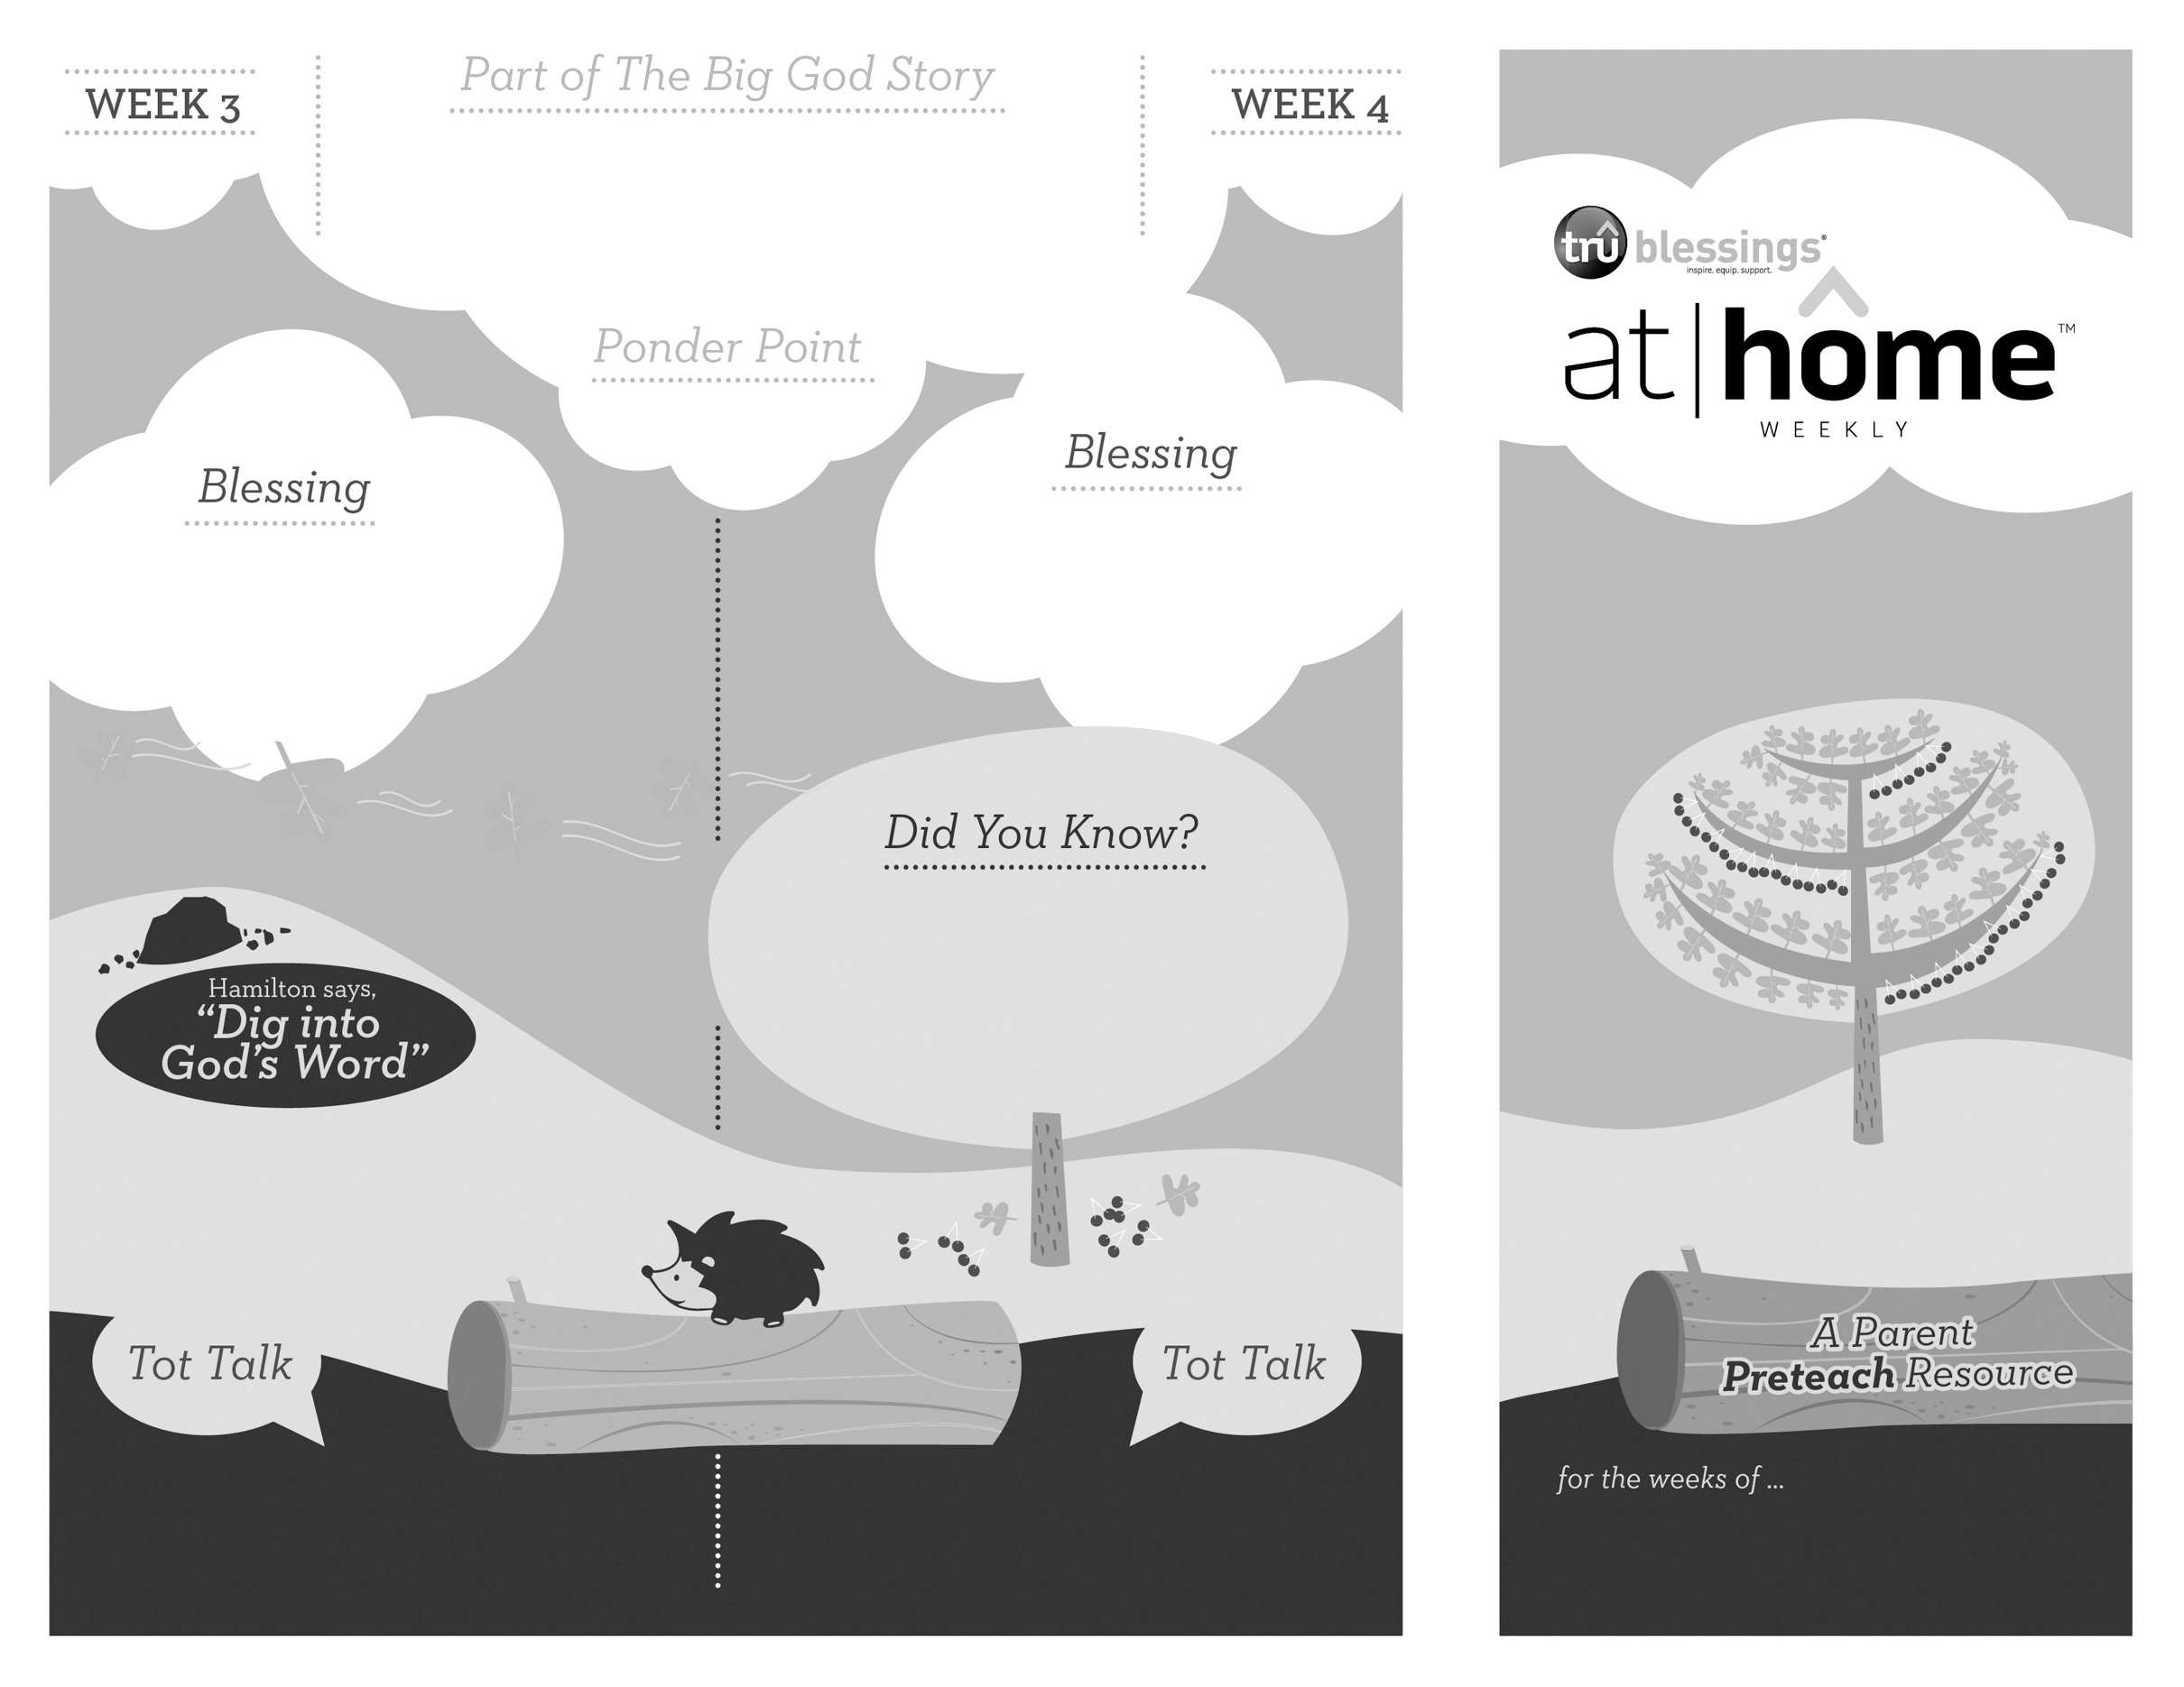

***Your child enjoys making believe and is developing his imagination. Allow him to choose some people   
to make pretend phone calls to, telling them that Jesus is the good news.***

***JESUS IS THE GOOD NEWS***

**Matthew 28:16–20**

Before Jesus ascended to heaven, He met with His apostles on a mountain in Galilee where He commissioned them to spread

the good news to all nations.

3.8

3.7

Open a Bible and read Isaiah 6:3b:

***“Holy, holy, holy is the Lord Almighty; the whole earth is full of his glory.”***

(Insert your child’s name)**,** **may you know that Jesus is the good news!**

***Read Matthew 28:19–20.*** Remind your child that Jesus is always with us, even though we can’t see Him.

• All eleven disciples were present with

Jesus when He told them to

spread the good news.

• The word “gospel” is a translation from an

Old English word *gōdspel*, which literally

means “good news.”

What did Jesus tell the apostles to do? Who did Jesus say would be with them?

Remind your child that Jesus wants us to tell everyone the good news. Discuss some people in your life who need to hear the gospel.

Type to enter text

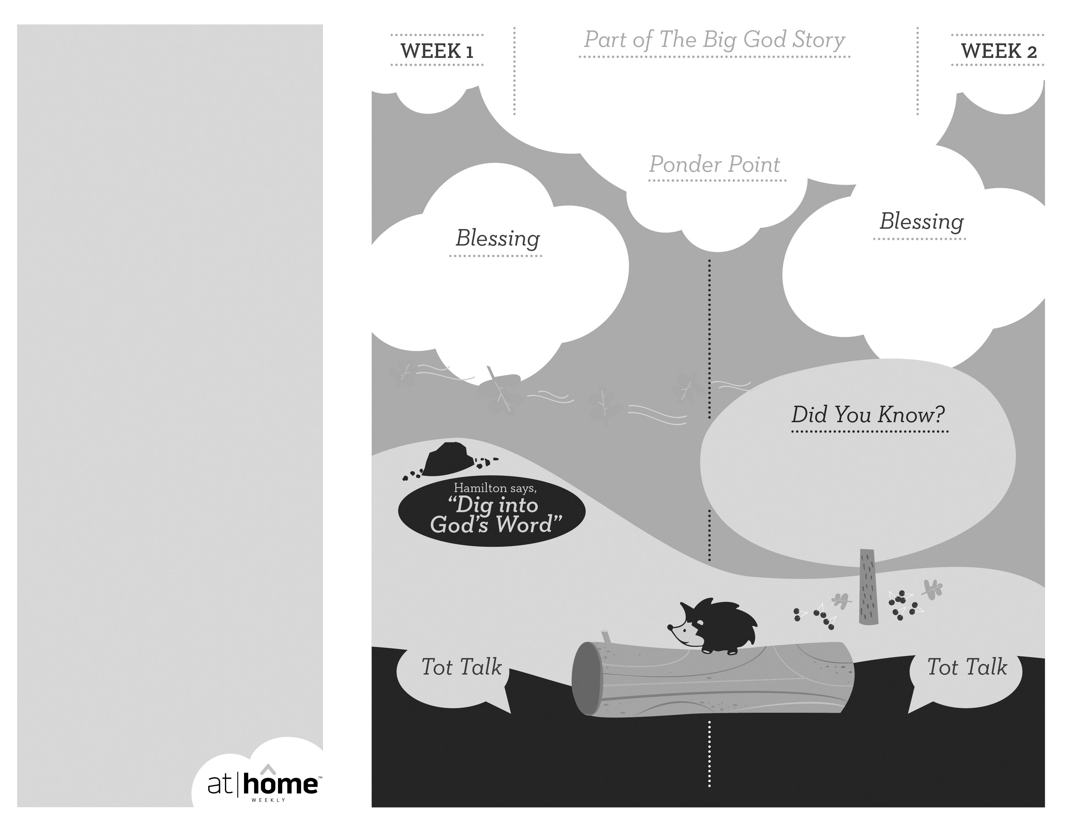

Why wasn’t Jesus in the tomb?

Because He is alive!

Open a Bible and read Revelation 1:8:

***“I am the Alpha and the Omega,” says the Lord God, “who is, and who was, and who is to come, the Almighty.”***

***JESUS IS ALIVE***

(Insert your child’s name),

**Jesus is alive! May you know His great love for you today and always.**

**John 19—20**

God had a plan to send a Savior. When the time was right, God sent His only Son, Jesus, who came to earth and died on a cross for our sins. After three days, He rose from the grave. Jesus is alive!

3.6

***God has given parents the***

***privilege of being the primary***

***spiritual nurturers of their***

***children’s faith.***

The At Home Weekly is designed to reinforce that truth by encouraging your family to have time in God’s Word **before your child attends** **church each week**. It will provide you with ways to introduce The Big God Story and have age-appropriate conversations with your little one as you prepare her for what she will be experiencing in church for the next four weeks.

Research has shown that children between the ages of two and four learn best through repetition. Because of this, TruBlessings will spend two weeks on the same part of **The Big God Story** and the **Ponder Point.**

Each week you will receive a new **Blessing.** A blessing is a prayer of commission, a portionof Scripture, or words of encouragement andguidance. While giving the blessing, you maydesire to lay hands on your child as you speak theScripture or pray a prayer over him.

**Hamilton the Hedgehog** will play a role in your child’s experience in church each week—be sure to ask about him. He loves to **Dig into God’s Word.** The passage of Scripture provided will assist you as you reinforce the Ponder Point. **Did You Know?** has fun facts about this part of The Big God Story for you to share with your child. And **Tot Talk** is simply a conversation starter to assist you as you spiritually parent.

3.5

© 2018 David C Cook. TruResources are developed in   
partnership with **ROCK**HARBOR Church and a   
national network of family and children’s ministry   
leaders. All rights reserved. Reproducible for  
church use only.

• Over 500 people saw Jesus alive

between the time of His resurrection

and His ascension into heaven.

• Some believe that the “stone” sealing

Jesus’ tomb could have weighed more

than a thousand pounds!

***Read John 20:1.*** Remind your child that the “stone” was really a large boulder!

***Your child can understand simple comparisons.***

***Play “full or empty” using a box with a lid and***

***some familiar household objects to help your***

***child begin to understand the empty tomb.***

Did Jesus stay dead?

No, He came back to life!