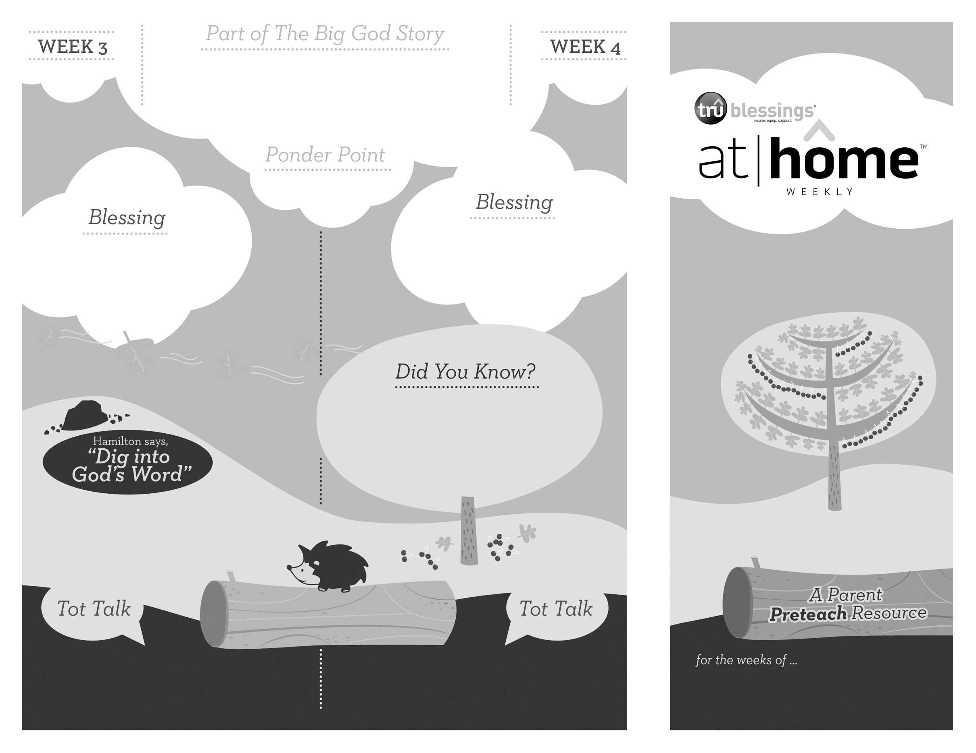

***Read Acts 12:4–7.*** After reading, remind your child that it was only through prayer that Peter’s freedom was possible. You may also want to say that Peter was in jail, but not because he had made bad choices. He had only obeyed God and was making good choices!

***GOD LISTENS TO OUR PRAYERS***

***Your child can learn about prayer and may enjoy folding her hands or***

***kneeling to pray.***

**Acts 12:1–19**

King Herod imprisoned Peter, putting him under heavy guard while he awaited his trial. Peter’s friends gathered to pray for him. God heard their prayers and sent an angel

to free Peter from prison.

3.12

3.11

Open a Bible and read Matthew 19:26: ***“Jesus looked at them and said,***

***‘… with God all things are possible.’”***

(Insert your child’s name)**,** **may you remember that no matter how hard something is, God can do anything, and He always listens to**

**your prayers.**

• The Sea of Galilee sits 686 feet below sea

level, and it’s not uncommon for violent

storms to arise producing waves over seven

feet high!

• Jesus slept soundly during the storm while

His disciples were fearing for their lives.

What are some things you pray about? Do you think God is listening when you pray?

Remind your child that prayer

is simply talking to God.

Type to enter text

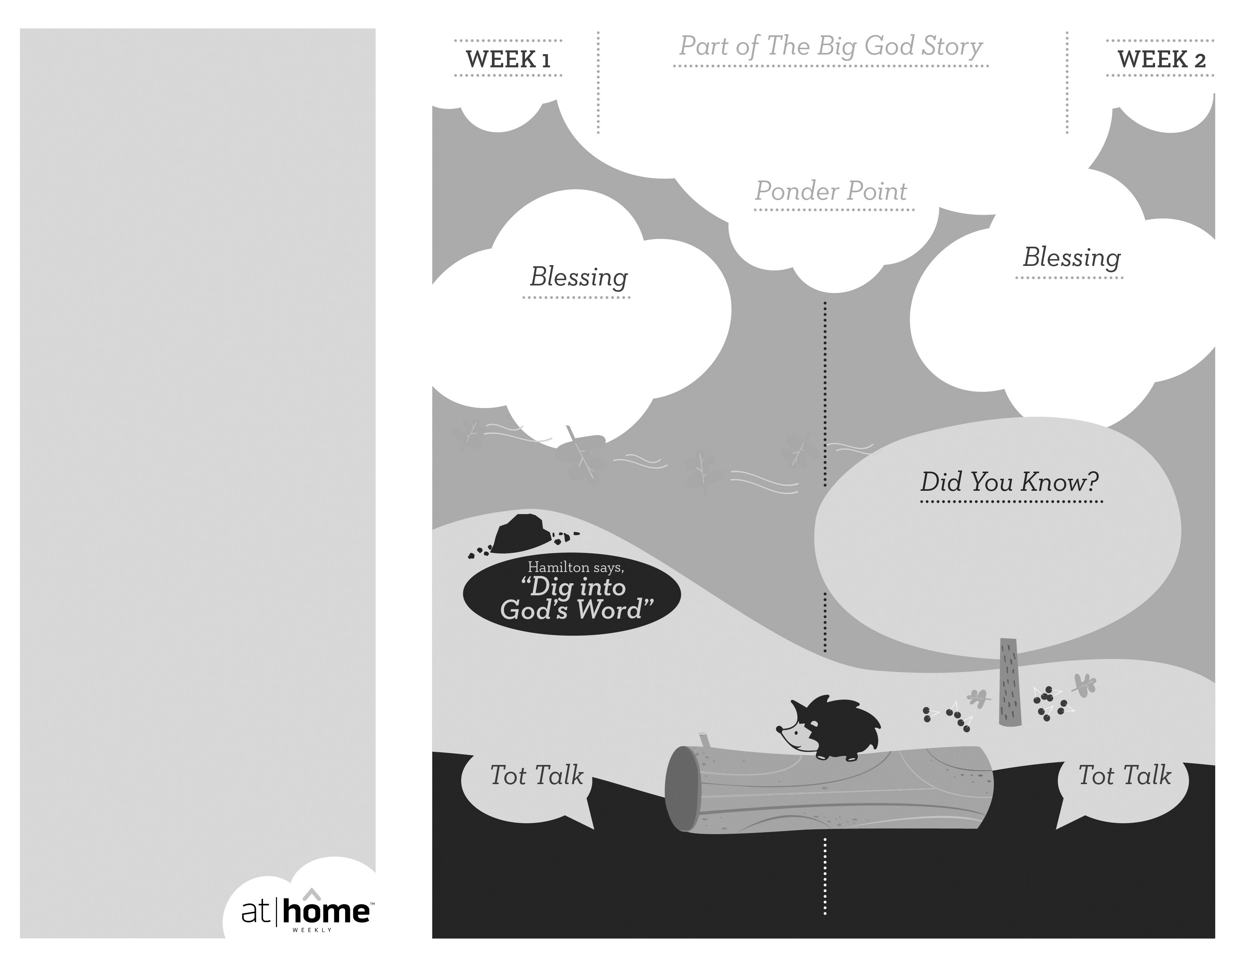

***Read Acts 11:27–30.*** Remind your child that it was God’s

love that prompted the church in Antioch to want to help

their brothers and sisters in Jerusalem.

• According to Acts 11:26, it was in Antioch that believers were first called “Christians.”

• Early Christians identified each other by drawing an arc in the sand, and if the other person drew a second arc (forming the shape of a fish) they   
knew they were both believers.

**Acts 11:19–30**

The apostles shared God’s love with the people in Antioch, and many of

them decided to follow Jesus. As Barnabas and Paul returned to teach, God’s love prompted the church in Antioch to help provide for the people in

Jerusalem who were facing a famine.

***GOD IS LOVE***

Open a Bible and read Psalm 36:7a:

***“How priceless is your unfailing***

***love, O God!”***

(Insert your child’s name)**,** **God is love. May you know how much He loves you.**

Remind your child that God’s love should help us to love other people. Discuss the ways your child

can show love to those around him.

3.10

***God has given parents the***

***privilege of being the primary***

***spiritual nurturers of their***

***children’s faith.***

The At Home Weekly is designed to reinforce that truth by encouraging your family to have time in God’s Word **before your child attends** **church each week**. It will provide you with ways to introduce The Big God Story and have age-appropriate conversations with your little one as you prepare her for what she will be experiencing in church for the next four weeks.

Research has shown that children between the ages of two and four learn best through repetition. Because of this, TruBlessings will spend two weeks on the same part of **The Big God Story** and the **Ponder Point.**

Each week you will receive a new **Blessing.** A blessing is a prayer of commission, a portionof Scripture, or words of encouragement andguidance. While giving the blessing, you maydesire to lay hands on your child as you speak theScripture or pray a prayer over him.

**Hamilton the Hedgehog** will play a role in your child’s experience in church each week—be sure to ask about him. He loves to **Dig into God’s Word.** The passage of Scripture provided will assist you as you reinforce the Ponder Point. **Did You Know?** has fun facts about this part of The Big God Story for you to share with your child. And **Tot Talk** is simply a conversation starter to assist you as you spiritually parent.

3.9

© 2018 David C Cook. TruResources are developed in   
partnership with **ROCK**HARBOR Church and a   
national network of family and children’s ministry   
leaders. All rights reserved. Reproducible for  
church use only.

***Praise your child’s effort to help with housework and remind him that helping your family honors God.***

Why were the people in Antioch taking care of each other?

The people loved God and others, just as God had asked them to.