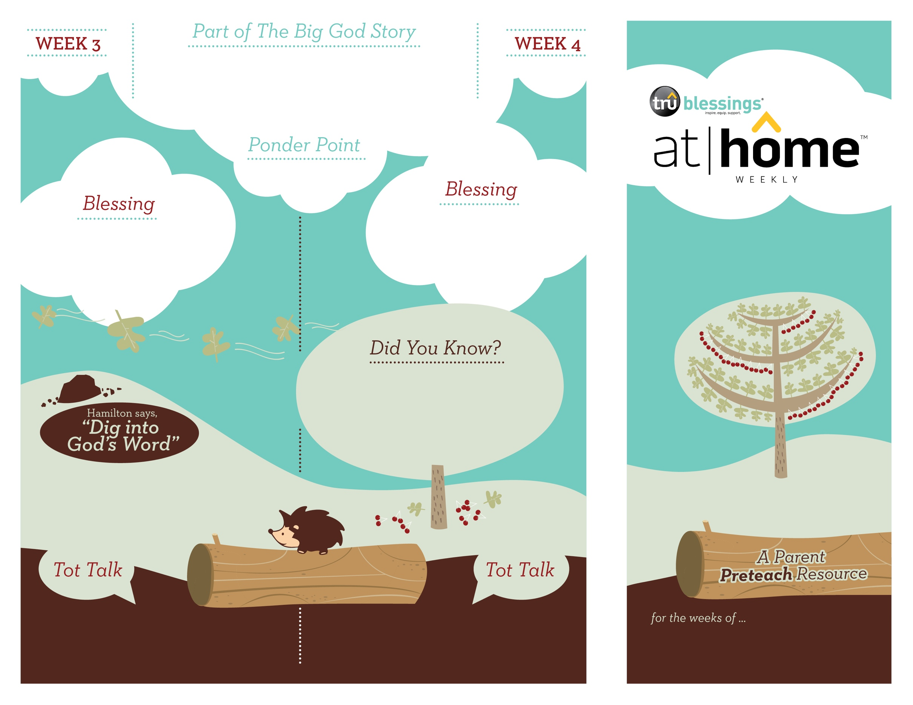

***Your child’s imagination is developing. During mealtime, allow your child to use her fork to “fly” her food to her mouth like the ravens flew to bring Elijah’s food.***

**1 Kings 17:1–6**

Elijah obeyed God’s words. Everything happened just as God had said. The ravens brought Elijah bread and meat to eat and he drank from the brook. God took care of Elijah.

Open a Bible and read 1 John 4:8b:

***“God is love.”***

***GOD TAKES CARE OF ME***

4.4

4.3

(Insert your child’s name)**,** **may you know that God cares for you and loves you.**

***Read Mark 4:35–41.*** After reading, remind your child that God used the ravens to bring food for Elijah every day.

• God sent the famine as judgment for King Ahab leading the nation of Israel into idol worship.

• Though it is uncertain how long Elijah stayed at the brook Kerith, many commentators believe it was at

least six months!

Who took care of Elijah while he was hiding at the brook? God cared for Elijah by sending the ravens to bring food.

If you were Elijah, what kind of food would

you have liked the ravens to bring you?

What kind of food did the ravens bring to Elijah?

Type to enter text

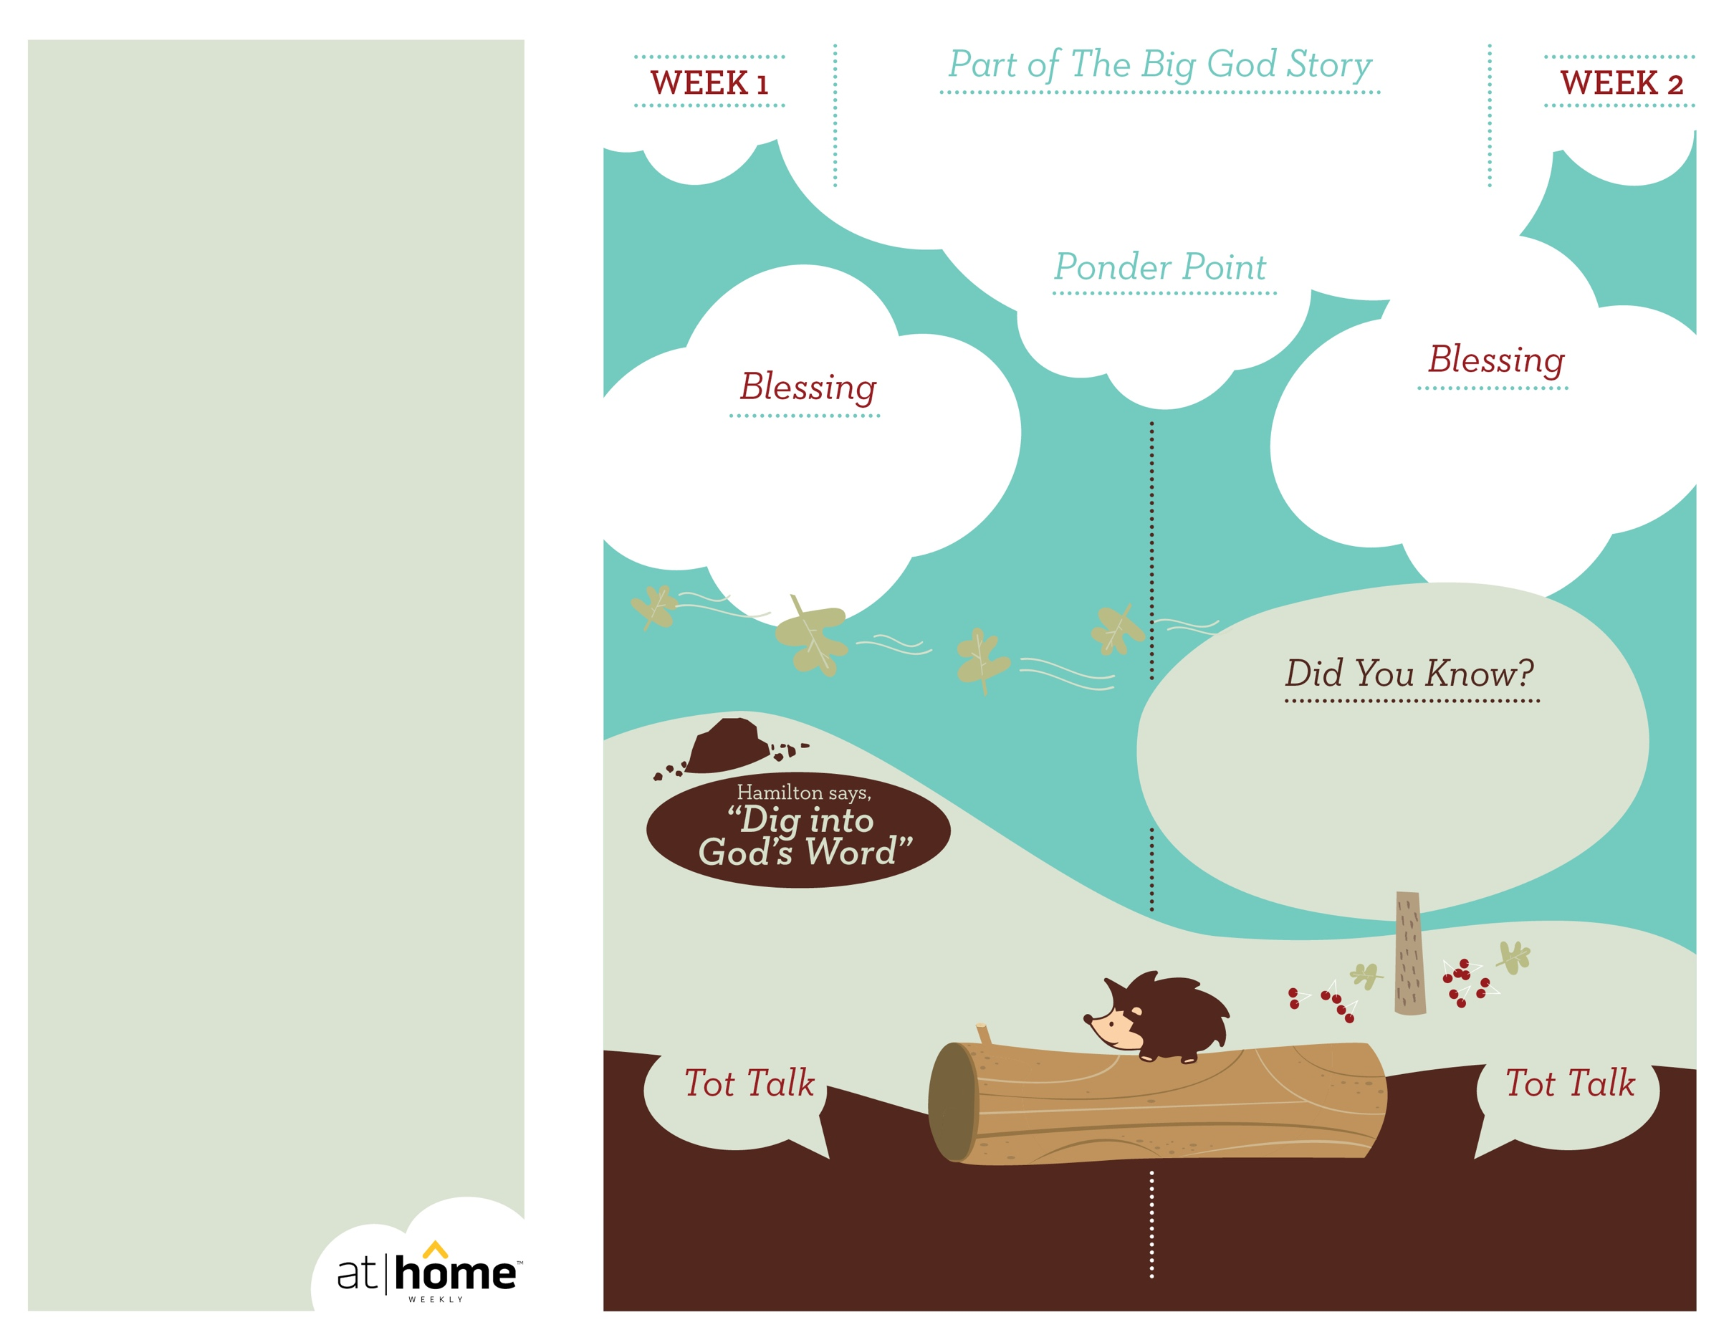

***Your child may enjoy looking at his reflection. Allow him to see his own power by flexing his muscles in a mirror.***

4.2

***GOD IS POWERFUL***

What does this part of The Big God Story tell

you about God? He is more powerful than

anything or anyone!

***Read 1 Samuel 17:32–37.*** After reading, remind your child that David wasn’t afraid because he knew God is more powerful than Goliath.

Open a Bible and read Psalm 68:35b:

***“The God of Israel gives power and strength to his people.***

***Praise be to God!”***

(Insert your child’s name)**,** **may you**

**learn to see God’s amazing power**

**in your life.**

***God has given parents the***

***privilege of being the primary***

***spiritual nurturers of their***

***children’s faith.***

The At Home Weekly is designed to reinforce that truth by encouraging your family to have time in God’s Word **before your child attends** **church each week**. It will provide you with ways to introduce The Big God Story and have age-appropriate conversations with your little one as you prepare her for what she will be experiencing in church for the next four weeks.

Research has shown that children between the ages of two and four learn best through repetition. Because of this, TruBlessings will spend two weeks on the same part of **The Big God Story** and the **Ponder Point.**

Each week you will receive a new **Blessing.** A blessing is a prayer of commission, a portionof Scripture, or words of encouragement andguidance. While giving the blessing, you maydesire to lay hands on your child as you speak theScripture or pray a prayer over him.

**Hamilton the Hedgehog** will play a role in your child’s experience in church each week—be sure to ask about him. He loves to **Dig into God’s Word.** The passage of Scripture provided will assist you as you reinforce the Ponder Point. **Did You Know?** has fun facts about this part of The Big God Story for you to share with your child. And **Tot Talk** is simply a conversation starter to assist you as you spiritually parent.

**1 Samuel 16—17**

God had rejected Saul as king and sent Samuel to the house of Jesse where he would choose Israel’s new king. Samuel anointed David. God’s Spirit was on David and when he fought Goliath, David was victorious.

4.1

© 2018 David C Cook. TruResources are developed in   
partnership with **ROCK**HARBOR Church and a   
national network of family and children’s ministry   
leaders. All rights reserved. Reproducible for  
church use only.

• David was the smallest and youngest of his

eight brothers. It surprised everyone when

Samuel anointed him as the future king.

• It’s possible that Goliath could have been

as much as nine and a half feet tall!

Why were the Israelites afraid of Goliath?

How did David beat Goliath?