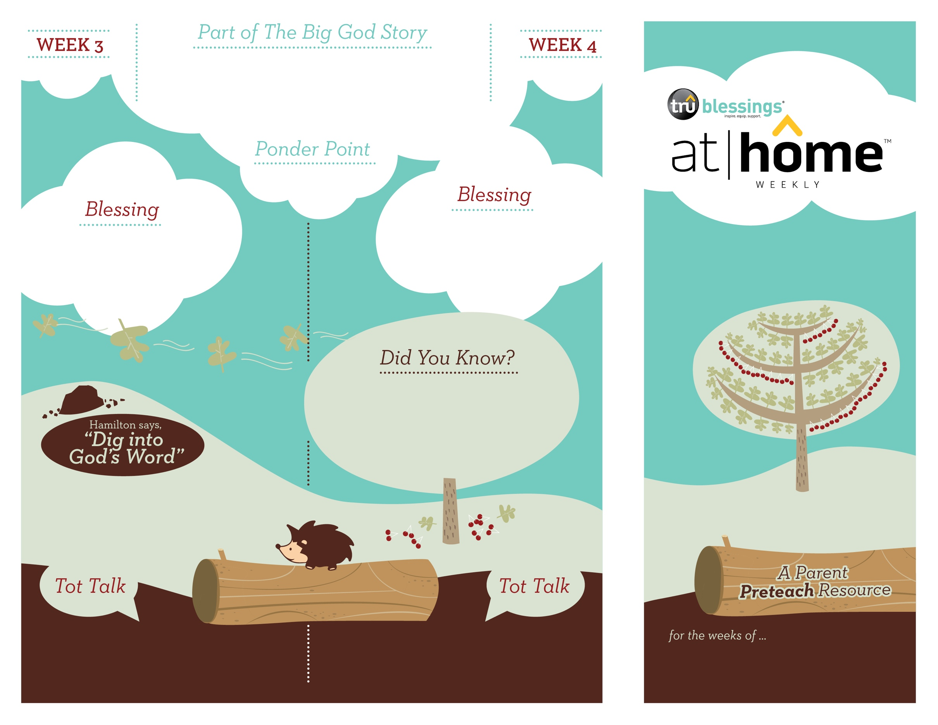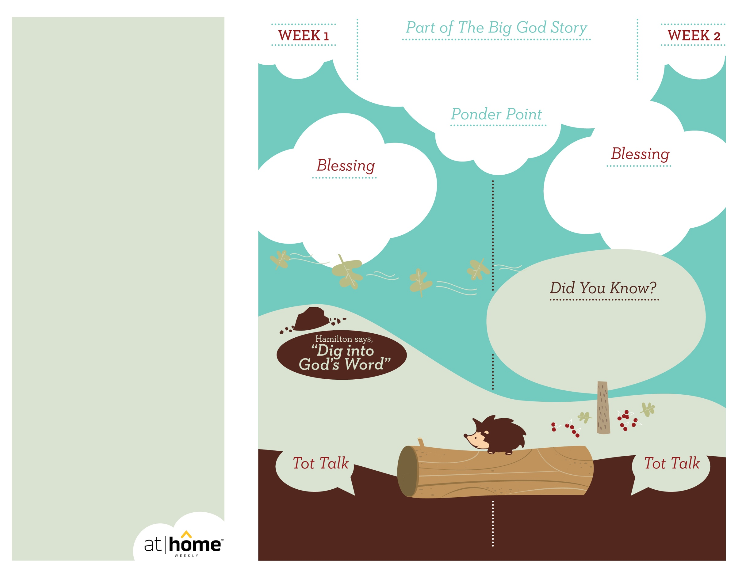

***GOD CARES FOR ME***

***Read Numbers 11:7–9.*** Remind your child how much God cared for the Israelites and how much He cares for us!

• The Israelites had never seen manna before; “manna” literally means “What is it?.”

• On the sixth day of the week, the Israelites could gather enough for two days because   
God wanted them to rest on the Sabbath.

**Exodus 16; Numbers 11:7–9**

After leaving Egypt, the Israelites had a long road ahead of them. The people started complaining early in the journey. God heard their grumbling and told Moses He would send food from heaven.   
He also gave special instructions about taking only enough food for each day. When the people woke up the ground was covered   
in manna. God cares for His people.

1.8

1.7

Open a Bible and read   
Psalm 139:14a:

***“I praise you because I am fearfully and wonderfully made.”***

(Insert your child’s name)**,** ***God loves you and takes care of you.***

How did God care for the Israelites? How does He care for you?

Have you ever thrown a fit or temper tantrum? What is a better way to explain that you are frustrated—using your words or throwing a fit?

***Your child needs consistent provision and love. Your consistency is the building block upon which your child learns that God cares for him.***

Type to enter text

***GOD IS MIGHTY***

***Your child may enjoy hearing the same stories over and over. As you tell him this part of The Big God Story, be sure to point out that it was God who was mighty enough to save the Israelites from the advancing army.***

**Exodus 14:13–15:21**

In an effort to gain control, the king of Egypt enslaved God’s people.   
The people cried out to God for rescue. He sent Moses to lead the people out of Egypt. When the Israelites reached the Red Sea there was no place to go. God is mighty. He sent a great wind to part the Red Sea.   
When the sea parted, the people were able to   
cross safely through on the dry seabed.

***God has given parents the privilege of being the primary spiritual nurturers of their children’s faith.***

The At Home Weekly is designed to reinforce that truth by allowing your family to have time in God’s Word**before your child attends church each week.** It will provide you with ways to introduce The Big God Story and have age-appropriate conversations with your little one as you prepare her for what she will be experiencing in church for the next four weeks.

Research has shown that children between the ages of two and four learn best through repetition. Because of this, TruBlessings will spend two weeks on the same part of **The Big God Story** and the **Ponder Point.**

Each week you will receive a new **Blessing.** A blessing is a prayer of commission, a portion of Scripture, or words of encouragement and guidance. While giving the blessing, you may desire to lay hands on your child as you speak the Scripture or pray a prayer over him.

**Hamilton the Hedgehog** will play a role in your child’s experience in church each week—be sure to ask about him. He loves to **Dig into God’s Word.** The passage of Scripture provided will assist you as you reinforce the Ponder Point. **Did You Know?** has fun facts about this part of The Big God Story for you to share with your child. And **Tot Talk** is simply a conversation starter to assist you as you spiritually parent.

1.6

1.5

© 2017 David C Cook. TruResources are developed in   
partnership with **ROCK**HARBOR Church and a   
national network of family and children’s ministry   
leaders. All rights reserved. Reproducible for  
church use only.

Open a Bible and read Psalm 150:6:

***“Let everything that has breath praise the Lord. Praise the Lord.”***

(Insert your child’s name)**,** ***God is mighty. You can always trust Him. May you praise and thank Him for who He is.***

• When Moses raised his staff, the Red Sea completely dried up so that the Israelites walked through on dry land!

• Moses’s sister, Miriam, led the people in worship after they had crossed the sea!

***Read Exodus 14:10–14; 15:19.*** Remind your child that our God is mightier than anyone or anything!

Do you think God’s people were scared when the army was chasing them? How do you think they felt when they crossed the Red Sea?

How did God show the people that He is mighty? He parted the Red Sea and saved them from the king and his army.