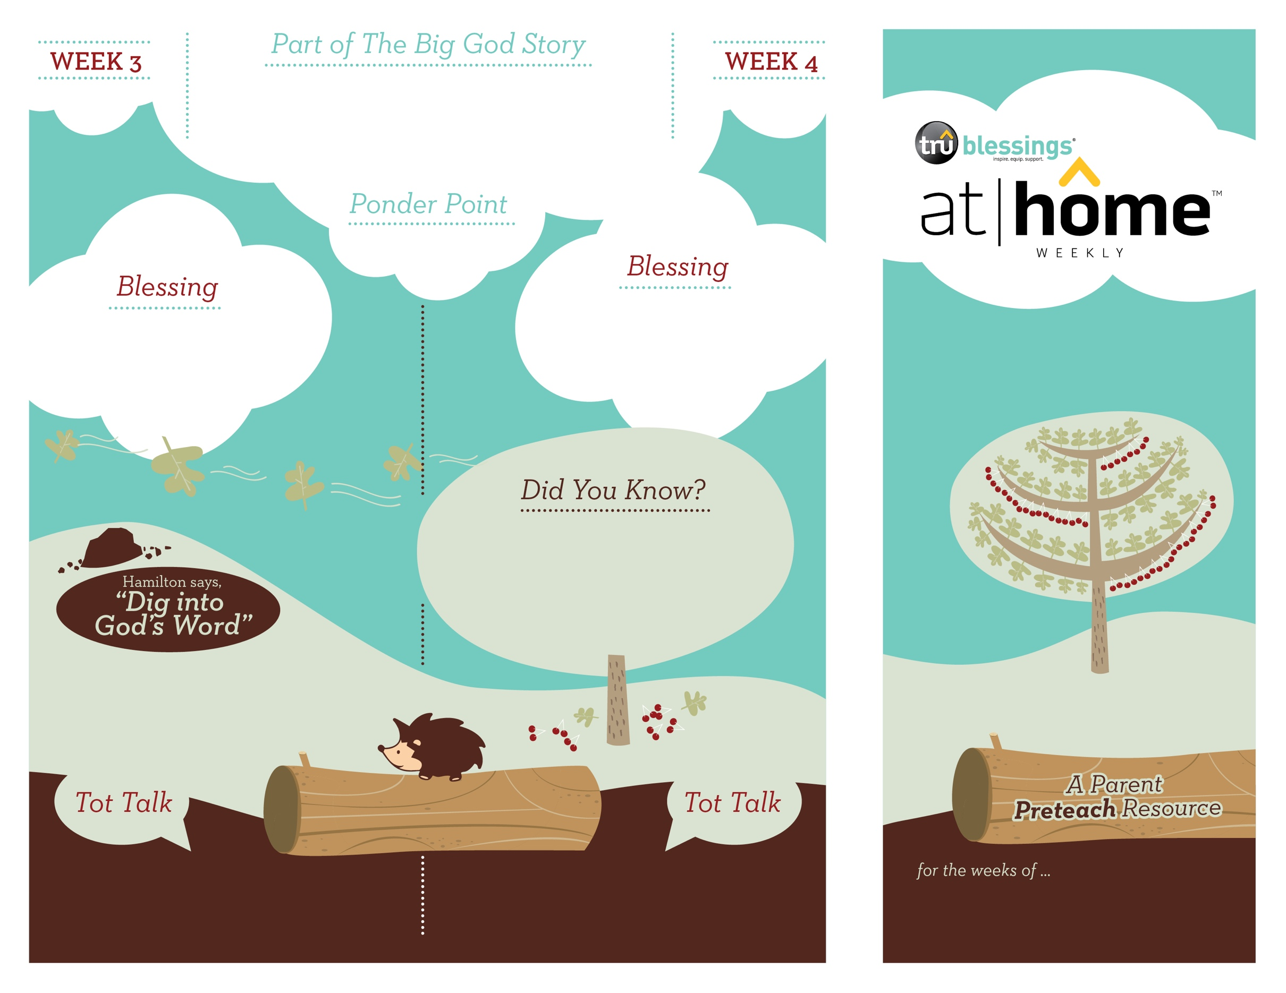

***Your child may enjoy playing with baby dolls. As she mimics caring for an infant, use this opportunity to tell her the Christmas story. Remind your child that Jesus was born as a baby.***

***Read Luke 2:8–12.*** After reading, ask your child whom the shepherds found in the manger. It was Jesus! Remind your child that we celebrate  
Christmas because Jesus, the promised Savior,  
was born!

Open a Bible and read Luke 2:14:

***“Glory to God in the highest, and on earth peace to men on whom his favor rests.”***

**Luke 2:8–20**

While the shepherds were watching their sheep at night, the sky lit up and an angel of the Lord appeared to them. The shepherds were terrified. The angel told them not to be afraid for he had come with good news. The Savior had been born. The Promise they had been waiting for had finally come!

***JESUS IS BORN***

2.4

2.3

(Insert your child’s name)**,** ***may you give glory to God for the gift of   
His Son, Jesus.***

• The shepherds were the first to hear that  
Jesus had been born. God sent angels to tell  
them that the Savior had come.

• After seeing Jesus, the shepherds praised  
God because they knew He had kept His  
promise to send a Savior.

Who told the shepherds that Jesus had come? An angel shared the good news with them!

Were the shepherds happy or sad when they saw Jesus? How did they show how happy they were? They praised God!

Type to enter text

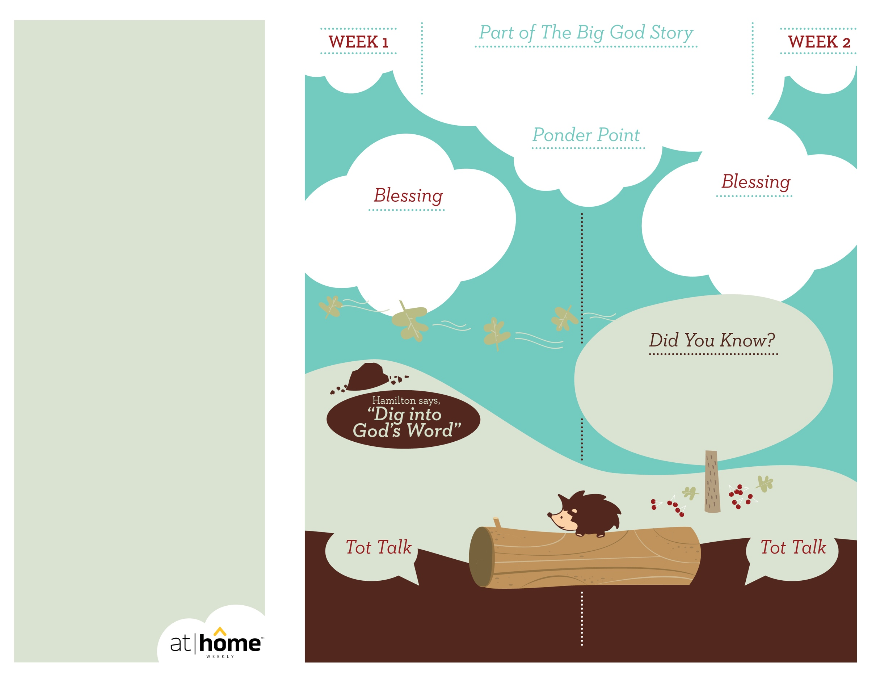

***One way children learn the faithfulness of God is through their parents. When we keep our promises and follow through with what we say, little ones are able to see how God keeps His promises.***

(Insert your child’s name)**,** ***may you always rejoice in God because He always keeps His promises.***

**Luke 1:26–56; Matthew 1:18–25**

Mary received the news that she was going to have a baby whom she was to name Jesus, the promised Savior. At the time she received this news, Mary was engaged to a man named Joseph. God told Joseph in a dream about the baby Jesus. He is the fulfillment of the promise God had made long ago to redeem mankind.

***God has given parents the privilege of being the primary spiritual nurturers of their children’s faith.***

The At Home Weekly is designed to reinforce that truth by allowing your family to have time in God’s Word**before your child attends church each week.** It will provide you with ways to introduce The Big God Story and have age-appropriate conversations with your little one as you prepare her for what she will be experiencing in church for the next four weeks.

Research has shown that children between the ages of two and four learn best through repetition. Because of this, TruBlessings will spend two weeks on the same part of **The Big God Story** and the **Ponder Point.**

Each week you will receive a new **Blessing.** A blessing is a prayer of commission, a portion of Scripture, or words of encouragement and guidance. While giving the blessing, you may desire to lay hands on your child as you speak the Scripture or pray a prayer over him.

**Hamilton the Hedgehog** will play a role in your child’s experience in church each week—be sure to ask about him. He loves to **Dig into God’s Word.** The passage of Scripture provided will assist you as you reinforce the Ponder Point. **Did You Know?** has fun facts about this part of The Big God Story for you to share with your child. And **Tot Talk** is simply a conversation starter to assist you as you spiritually parent.

***GOD KEEPS  
HIS PROMISE***

2.2

2.1

© 2017 David C Cook. TruResources are developed in   
partnership with **ROCK**HARBOR Church and a   
national network of family and children’s ministry   
leaders. All rights reserved. Reproducible for  
church use only.

Open a Bible and read Luke 1:46–47:

***“Mary said: ‘My soul glorifies the Lord and my spirit rejoices in God my Savior.’”***

• At the same time Mary was carrying Jesus,  
her cousin Elizabeth was also carrying a  
baby who was John the Baptist.

• It was an angel who told Mary and Joseph  
to give the baby the name Jesus.

***Read Genesis 1:26–31.*** After reading, remind   
your child that God created the world and everything in it.

Was Mary happy or sad when the angel told her she was going to have a baby? Mary was troubled when she saw the angel and heard his message, but full of joy when she understood.

Who is the Savior that God promised to send?

Jesus is the promised Savior!