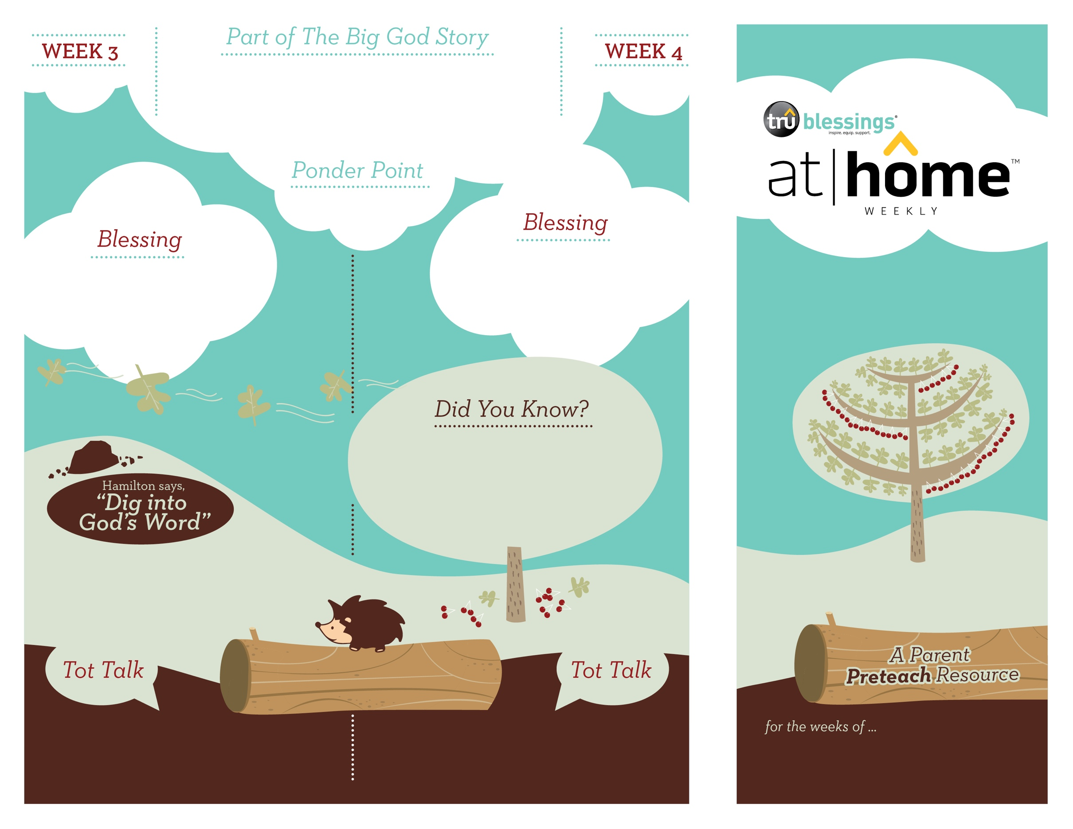

***JESUS IS POWERFUL***

**John 9:1–12**

Jesus displayed God’s power by healing a man

who had been born blind.

2.12

2.11

Open a Bible and read Psalm 147:5a:

***“Great is our Lord and mighty in power.”***

(Insert your child’s name)**,** **I pray**

**you will understand that Jesus is**

**bigger and more powerful than**

**anything this world has to offer.**

***Read John 9:6–11.*** Remind your child that Jesus was the only one who had the power to heal the blind man.

• The Pharisees did not think Jesus was a

man of God because He healed on the

Sabbath, a day on which the Jewish people

were prohibited from working.

• The man Jesus healed had been blind

his whole life!

Why did Jesus heal the blind man?

To show His power!

Discuss together what the blind man did after

Jesus healed him.

***Your child enjoys music and can perform***

***simple hand motions. Sing “Jesus Loves Me”***

***and make up some gestures your child***

***can imitate.***

Type to enter text

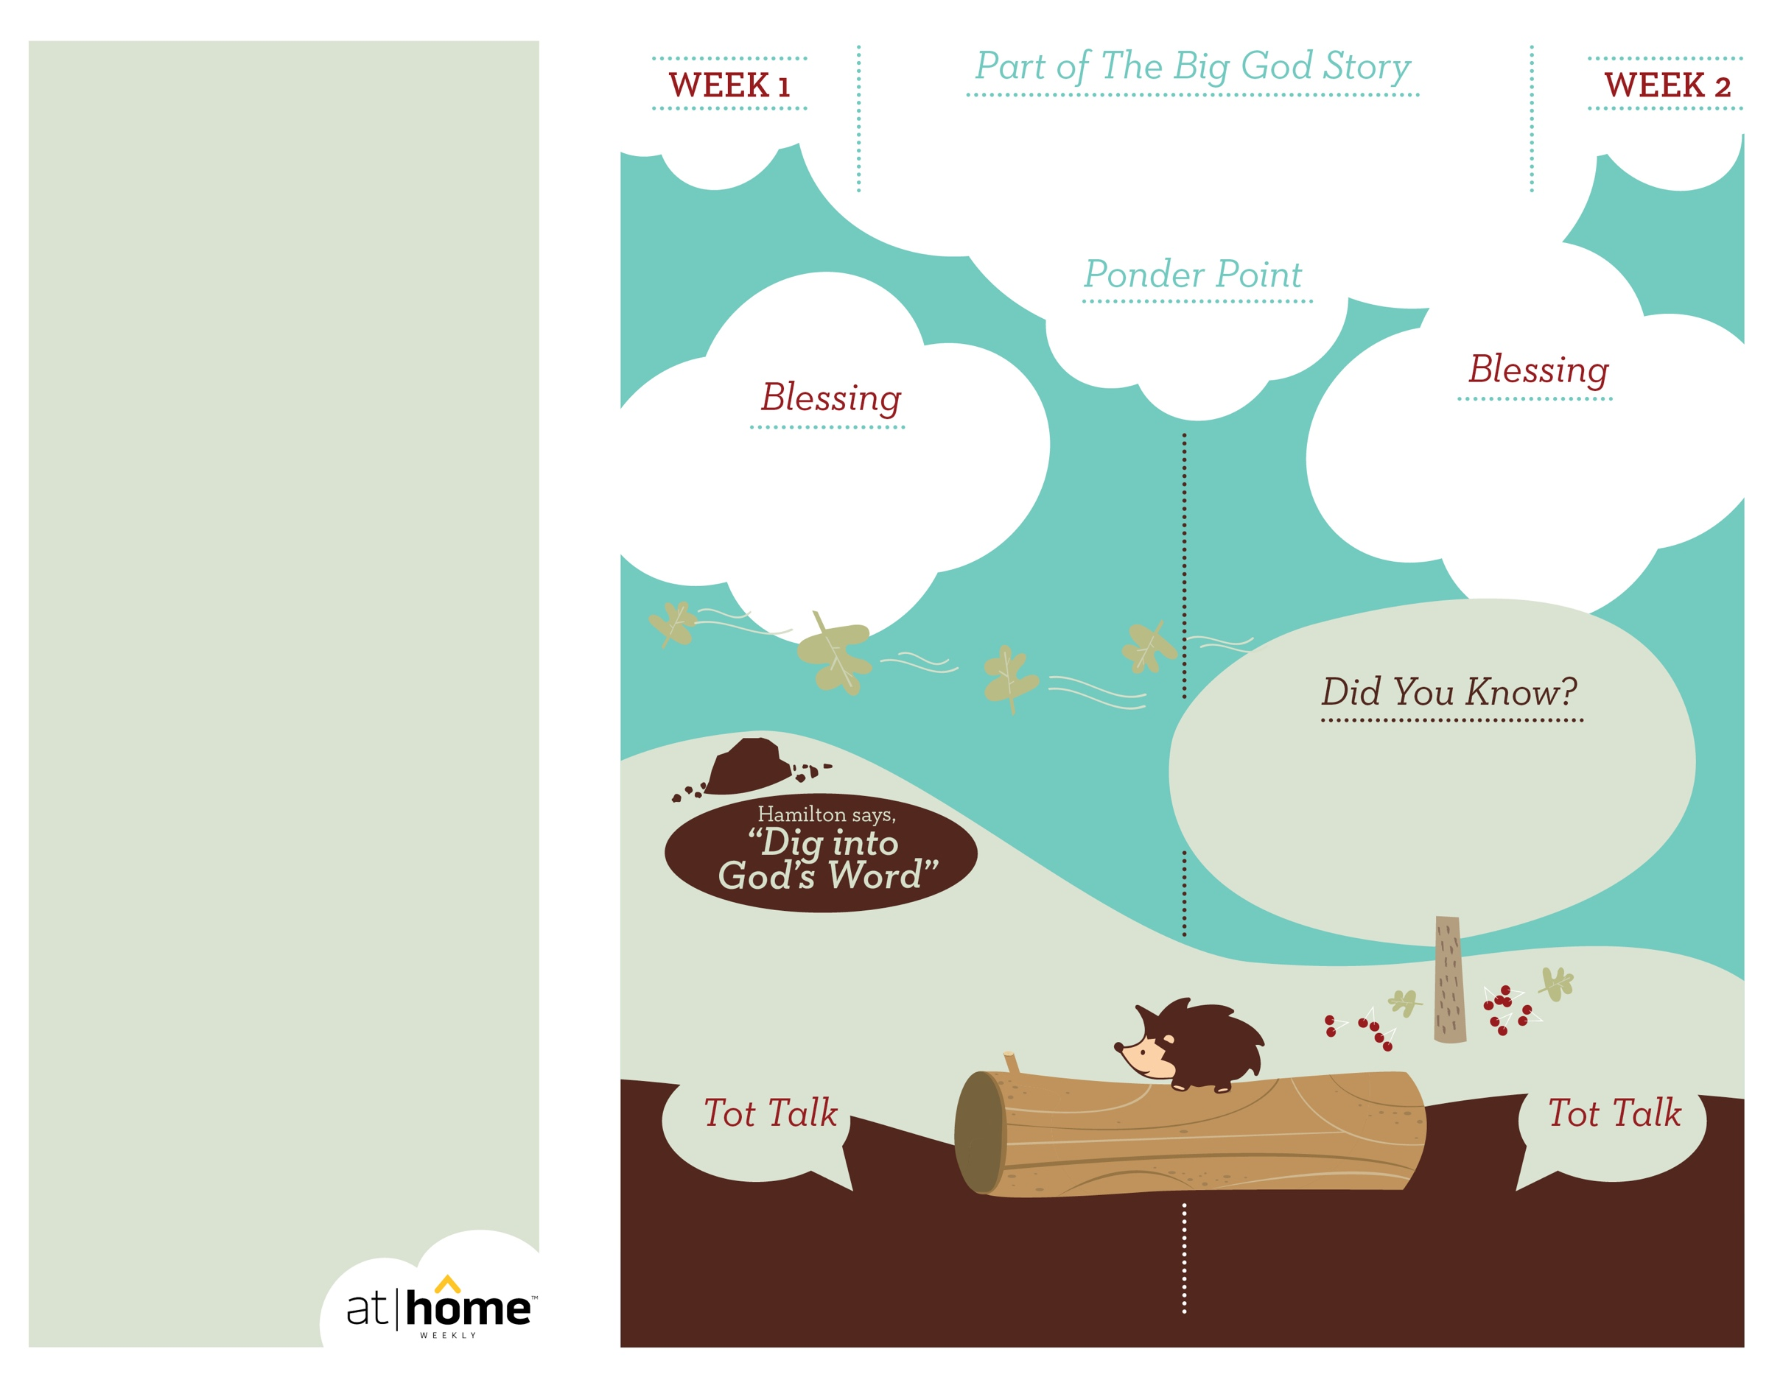

2.10

(Insert your child’s name)**,** **I pray**

**that you will come to know Jesus as**

**your shepherd, and know that He**

**cares for you every day.**

**Matthew 14:13–21; Mark 6:30–44; Luke 9:10–17; John 6:1–15**

Jesus cared so much for the crowd following Him that

He taught the people, healed them, and fed them. Jesus provides abundantly for us because He cares for us.

***God has given parents the***

***privilege of being the primary***

***spiritual nurturers of their***

***children’s faith.***

The At Home Weekly is designed to reinforce that truth by encouraging your family to have time in God’s Word**before your child attends church each week.** It will provide you with ways to introduce The Big God Story and have age-appropriate conversations with your little one as you prepare her for what she will be experiencing in church for the next four weeks.

Research has shown that children between the ages of two and four learn best through repetition. Because of this, TruBlessings will spend two weeks on the same part of **The Big God Story** and the **Ponder Point.**

Each week you will receive a new **Blessing.** A blessing is a prayer of commission, a portion of Scripture, or words of encouragement and guidance. While giving the blessing, you may desire to lay hands on your child as you speak the Scripture or pray a prayer over him.

**Hamilton the Hedgehog** will play a role in your child’s experience in church each week—be sure to ask about him. He loves to **Dig into God’s Word.** The passage of Scripture provided will assist you as you reinforce the Ponder Point. **Did You Know?** has fun facts about this part of The Big God Story for you to share with your child. And **Tot Talk** is simply a conversation starter to assist you as you spiritually parent.

***JESUS CARES***

2.9

© 2017 David C Cook. TruResources are developed in   
partnership with **ROCK**HARBOR Church and a   
national network of family and children’s ministry   
leaders. All rights reserved. Reproducible for  
church use only.

Open a Bible and read Psalm 23:1:

***“The Lord is my shepherd;***

***I lack nothing.”***

• There were 5,000 men in the

crowd, but there were probably several

thousand more people there since that

number does not include the women

and children who were present.

• After Jesus fed the 5,000, there

were 12 baskets of leftovers!

***Read Mark 6:34.*** Let your child know that a

shepherd’s job is to take care of the sheep and

keep them safe.

***Balls are a favorite toy. Find a wide-open***

***space and allow your little one to test his***

***own power by seeing how far he can throw!***

Why did Jesus feed the crowd?

Because Jesus cared for them!

Discuss with your child some tangible ways we can

show other people how much Jesus cares about

them—using kind words, showing affection, etc.