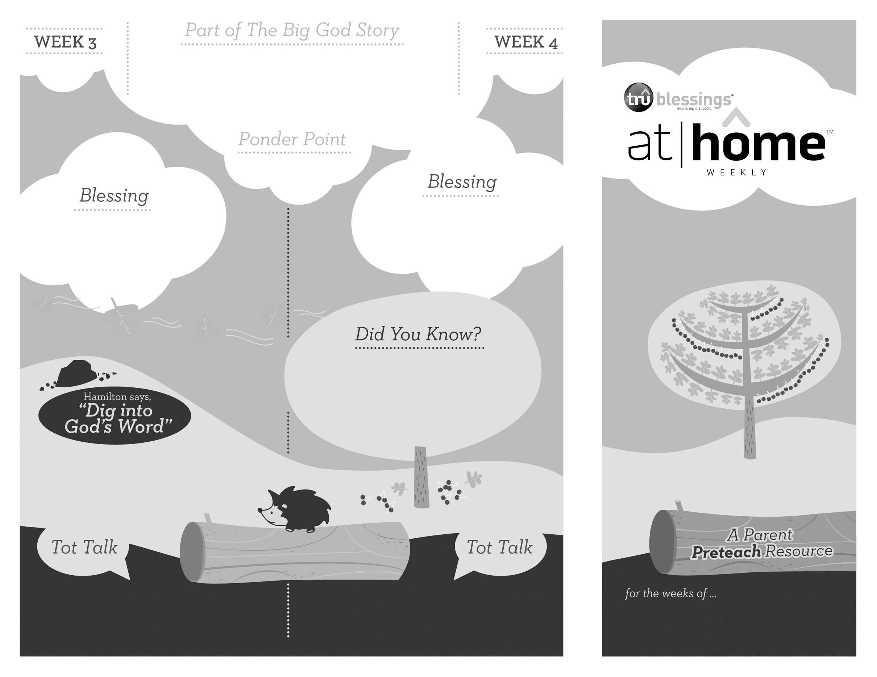­­

***GOD MADE PEOPLE***

1.4

1.3

**Genesis 1:26–31; 2:4–25**

On the sixth day, God gave the first man the breath of life. God named him Adam. The Lord saw that it was not good for man to be alone, so He created Eve. Adam and Eve lived in a beautiful garden where they walked and talked with God.

Open a Bible and read

Psalm 139:14a:

***“I praise you because I am fearfully and***   
***wonderfully made.”***

(Insert your child’s name)**,** ***may you always remember that you are special, made by God too.***

***Read Genesis 2:7; 2:18–23.*** Remind your children that God made them and loves them.

• God created man and woman in   
His own image.

• When Adam and Eve were created,   
they walked and talked with God   
in perfect relationship.

Who made you? God made you!

What would you say to God if you could walk   
with and talk to Him like Adam and Eve did?

***Your child may enjoy gazing at his own reflection. As he does so, remind him that God made him and all of the people in the world.***

Type to enter text

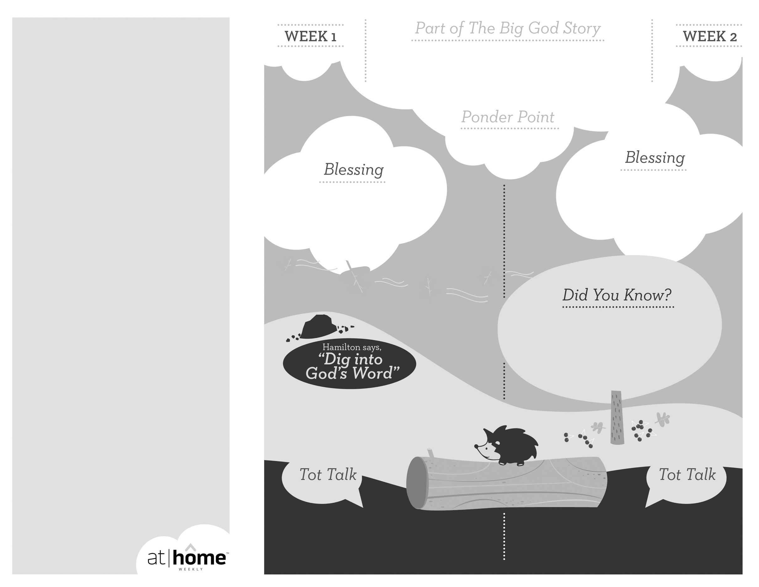

***It may seem that your child wants to touch, smell, or taste everything he comes in contact with. Sensory experiences help him learn about the world around him and remind him that God created the world and everything in it.***

***God has given parents the privilege of being the primary spiritual nurturers of their children’s faith.***

The At Home Weekly is designed to reinforce that truth by allowing your family to have time in God’s Word**before your child attends church each week.** It will provide you with ways to introduce The Big God Story and have age-appropriate conversations with your little one as you prepare her for what she will be experiencing in church for the next four weeks.

Research has shown that children between the ages of two and four learn best through repetition. Because of this, TruBlessings will spend two weeks on the same part of **The Big God Story** and the **Ponder Point.**

Each week you will receive a new **Blessing.** A blessing is a prayer of commission, a portion of Scripture, or words of encouragement and guidance. While giving the blessing, you may desire to lay hands on your child as you speak the Scripture or pray a prayer over him.

**Hamilton the Hedgehog** will play a role in your child’s experience in church each week—be sure to ask about him. He loves to **Dig into God’s Word.** The passage of Scripture provided will assist you as you reinforce the Ponder Point. **Did You Know?** has fun facts about this part of The Big God Story for you to share with your child. And **Tot Talk** is simply a conversation starter to assist you as you spiritually parent.

***GOD MADE  
OUR WORLD***

1.2

1.1

© 2017 David C Cook. TruResources are developed in   
partnership with **ROCK**HARBOR Church and a   
national network of family and children’s ministry   
leaders. All rights reserved. Reproducible for  
church use only.

**Genesis 1:1—2:3**

In six days, God created our world. Everything from the heavens and earth to the animals and people who inhabit it—the Lord created them all. On the seventh day He rested. God has entrusted His creation to our care.

Open a Bible and read Psalm 19:1:

***“The heavens declare the glory of God;***   
***the skies proclaim the work***   
***of his hands.”***

(Insert your child’s name)**, *may you worship God, remembering that it was He who created the world and everything in it.***

• During the first six days of creation,   
God created the world and   
everything in it.

• On the seventh day of the creation,   
God rested.

***Read Genesis 1:26–31.*** After reading, remind   
your child that God created the world and everything in it.

Who made our world? God did!

Whose job is it to care for God’s creation? Ours!