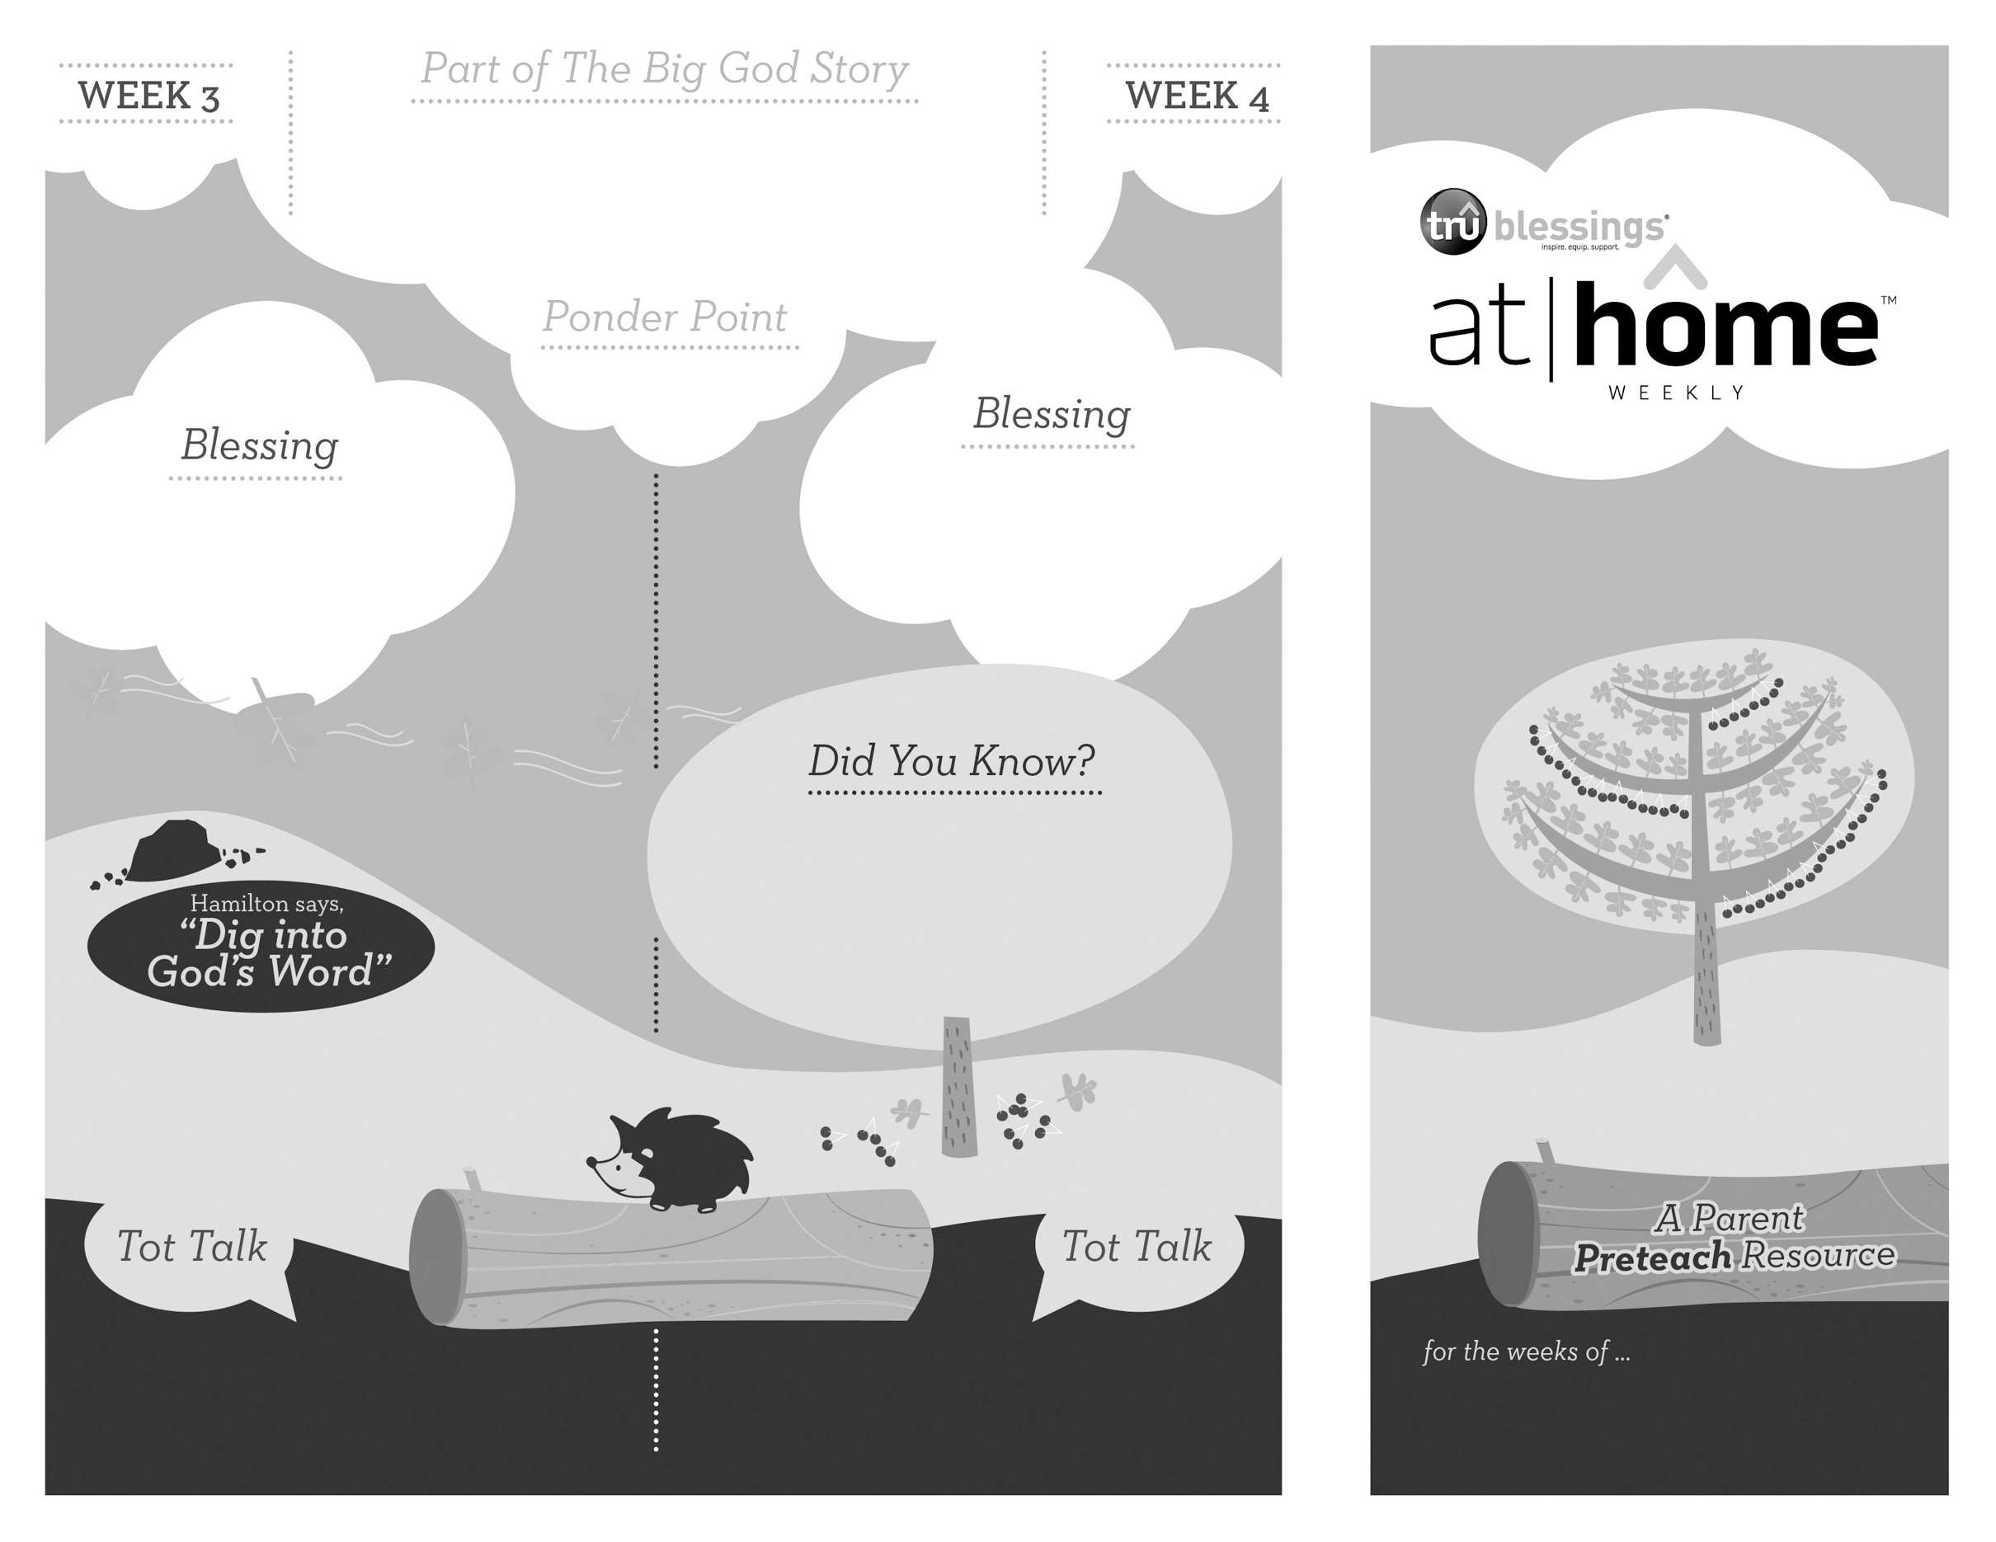

***Your child is beginning to develop his***

***imagination. Make some waves during bath***

***time and allow him to act out this part of***

***The Big God Story.***

**Matthew 8:23–27; Mark 4:35–41**

Jesus calms the storm with just three words: “Quiet! Be still!”

Jesus can control nature—He can save the world.

***JESUS IS GOD***

2.8

2.7

Open a Bible and read John 20:31a:

***“But these are written that you***

***may believe that Jesus is the Messiah, the Son of God.”***

(Insert your child’s name)**,** **I pray**

**you will come to understand**

**and know that Jesus is God and**

**experience how amazing He is.**

***Read Mark 4:35–41.*** After reading remind your

child that Jesus can control the waves with just

His words.

• The Sea of Galilee sits 686 feet below sea

level, and it’s not uncommon for violent

storms to arise producing waves over seven

feet high!

• Jesus slept soundly during the storm while

His disciples were fearing for their lives.

What does this part of The Big God

Story tell you about Jesus? That’s right,

He is all-powerful.

What was Jesus doing during the storm?

Sleeping! That’s right … Jesus wasn’t scared,

because He is God and that’s amazing.

Type to enter text

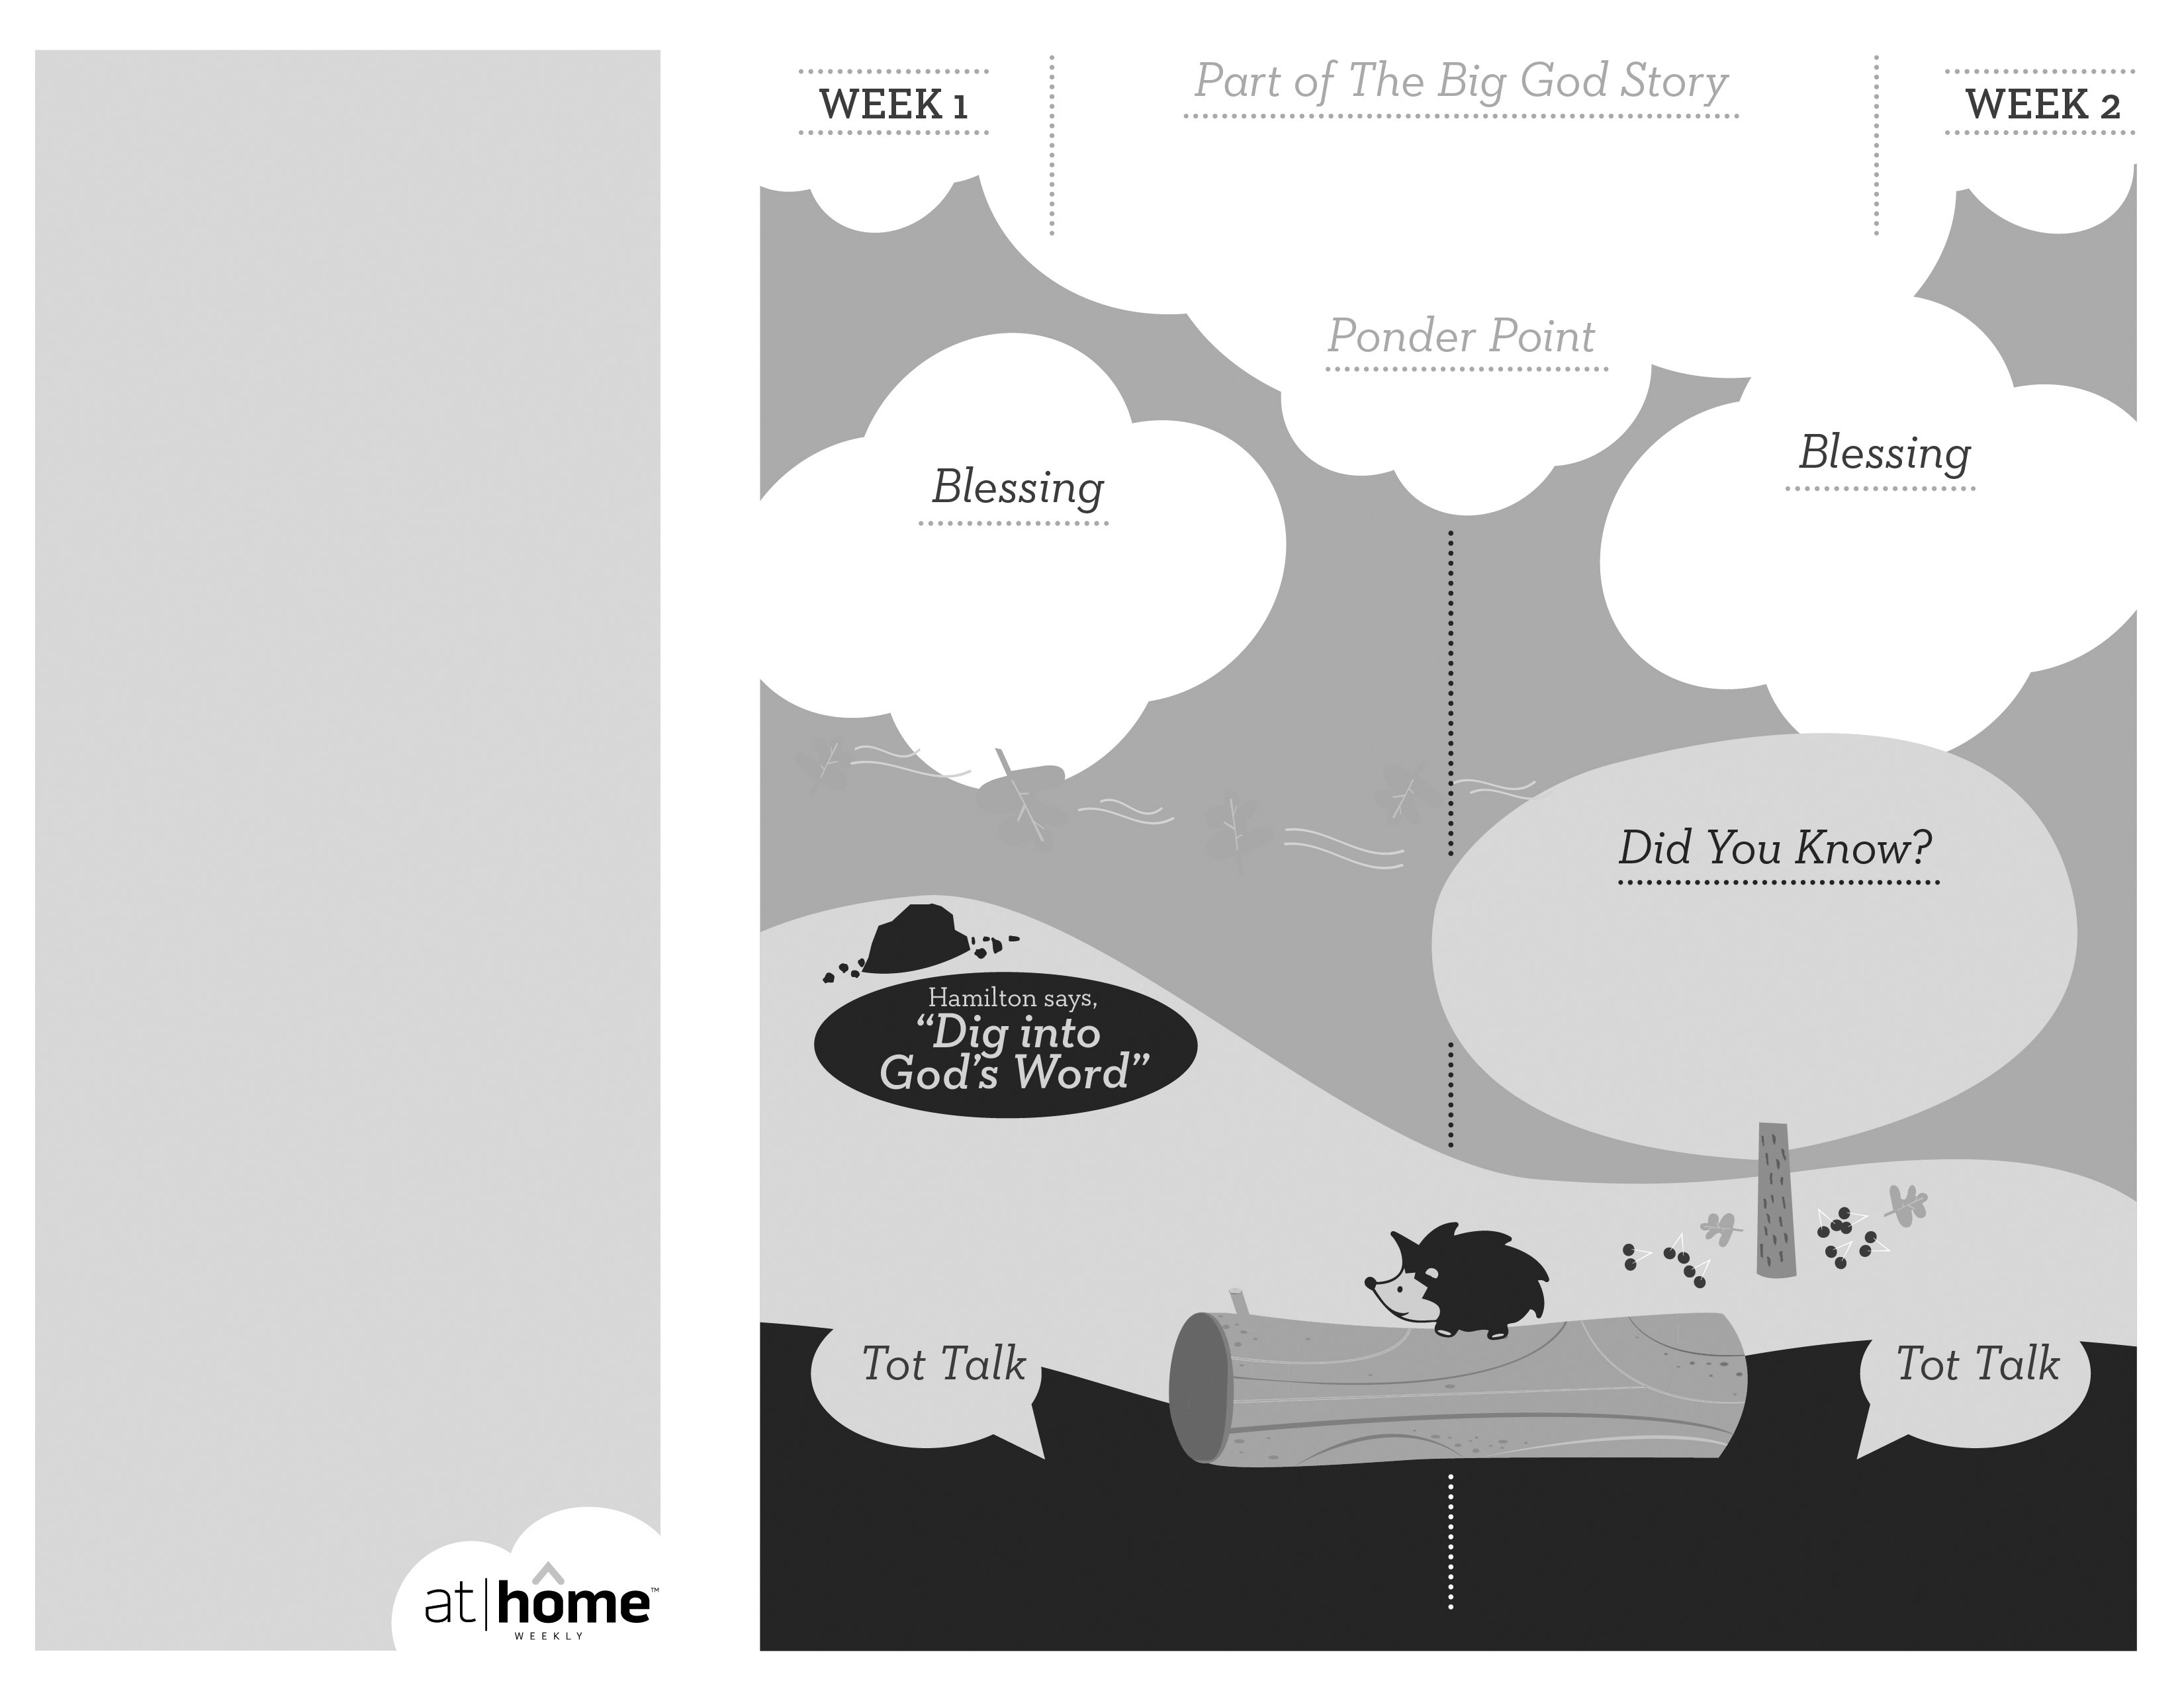

***JESUS CHOOSES US***

***TO FOLLOW HIM***

Open a Bible and read Colossians 2:6:

***“So then, just as you received Christ***

***Jesus as Lord, continue to live your***

***lives in him.”***

(Insert your child’s name)**,** **I pray**

**that you will come to know Jesus**

**early in your life and follow Him all**

**of your days.**

Remind your child that he can know and follow

Jesus. Discuss the ways together—loving others,

talking to God, learning more about Him, etc.

**Luke 5:1–11**

Jesus chose 12 apostles and prepared them to go and tell others about Him. Today He calls each of us to follow Him as well.

2.6

***God has given parents the***

***privilege of being the primary***

***spiritual nurturers of their***

***children’s faith.***

The At Home Weekly is designed to reinforce that truth by encouraging your family to have time in God’s Word **before your child attends** **church each week**. It will provide you with ways to introduce The Big God Story and have age-appropriate conversations with your little one as you prepare her for what she will be experiencing in church for the next four weeks.

Research has shown that children between the ages of two and four learn best through repetition. Because of this, TruBlessings will spend two weeks on the same part of **The Big God Story** and the **Ponder Point.**

Each week you will receive a new **Blessing.** A blessing is a prayer of commission, a portionof Scripture, or words of encouragement andguidance. While giving the blessing, you maydesire to lay hands on your child as you speak theScripture or pray a prayer over him.

**Hamilton the Hedgehog** will play a role in your child’s experience in church each week—be sure to ask about him. He loves to **Dig into God’s Word.** The passage of Scripture provided will assist you as you reinforce the Ponder Point. **Did You Know?** has fun facts about this part of The Big God Story for you to share with your child. And **Tot Talk** is simply a conversation starter to assist you as you spiritually parent.

2.5

© 2017 David C Cook. TruResources are developed in   
partnership with **ROCK**HARBOR Church and a   
national network of family and children’s ministry   
leaders. All rights reserved. Reproducible for  
church use only.

• If young students were considered to be

the cream of the crop, the rabbi would

accept the student as his disciple by

saying, “Come, follow me.”

• When Jesus called the first apostles

He said, “Come, follow Me.”

***Read Mark 1:16–18****.* Remind your child that

fishing for people simply means going and telling others about Jesus.

***Your child loves to imitate and understands***

***simple directions. Play a creative game of***

***Follow the Leader. Be sure and start it out***

***by saying, “Come, follow me!”***

***world and everything in it.***

What did Jesus say to the fishermen?

How did they respond?