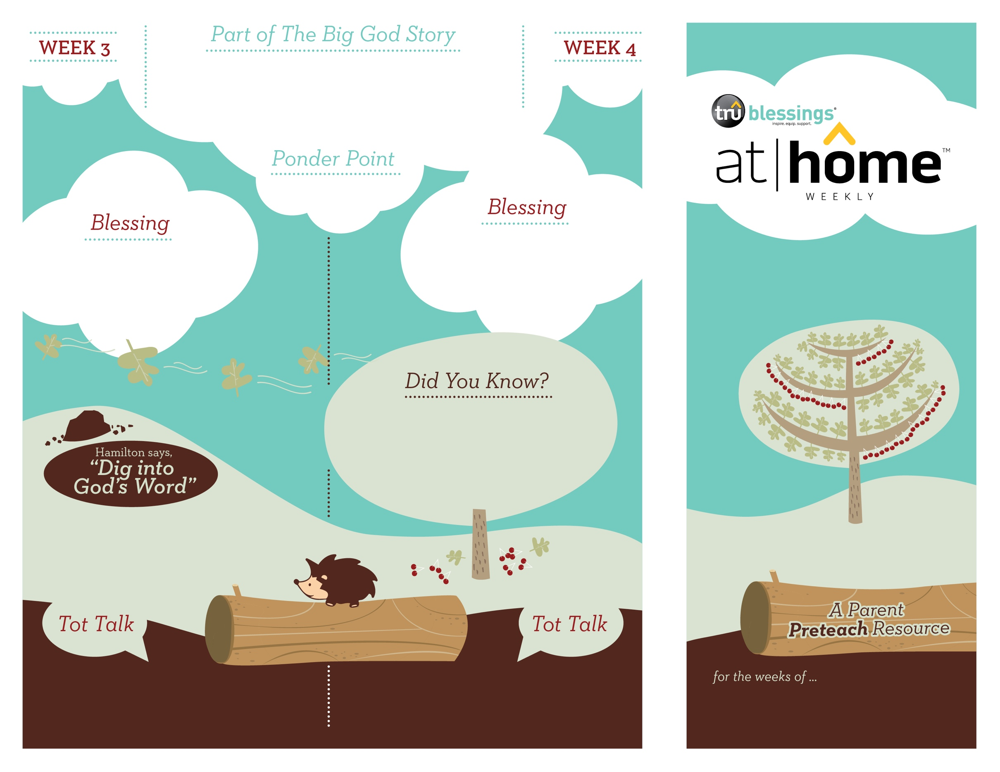

**Matthew 21:1–11; Mark 11:1–11; Luke 19:28–38**

Jesus rode into Jerusalem on a donkey. As Jesus rode into the city,

the people celebrated while they shouted, “Hosanna, Hosanna!”

What kind of animal did Jesus ride into Jerusalem? That’s right! Jesus rode in on a donkey.

***Your child enjoys role-play and dress-up. Allow your child to dress as royalty. Be sure to include a discussion about Jesus, our true King who loves us!***

What did the people say when Jesus came riding into Jerusalem? “Hosanna!” “Blessed is the king!”

***Read Matthew 21:7–9.*** After reading, let your child know that by spreading their garments on the road in front of Jesus, the people were honoring Him as King.

***JESUS IS KING***

3.4

3.3

Open a Bible and read Zechariah 9:9: ***“Rejoice! … Your king comes to you, righteous and victorious, lowly and riding on a donkey.”***

(Insert your child’s name)**,**

***May you come to know Jesus as your Savior and King.***

• We celebrate Jesus’ triumphal

entry into Jerusalem on Palm Sunday.

• Just before coming to Jerusalem, Jesus had raised Lazarus from the dead. This news doubtless made   
the crowds eager to see and honor   
Jesus as King.

Type to enter text

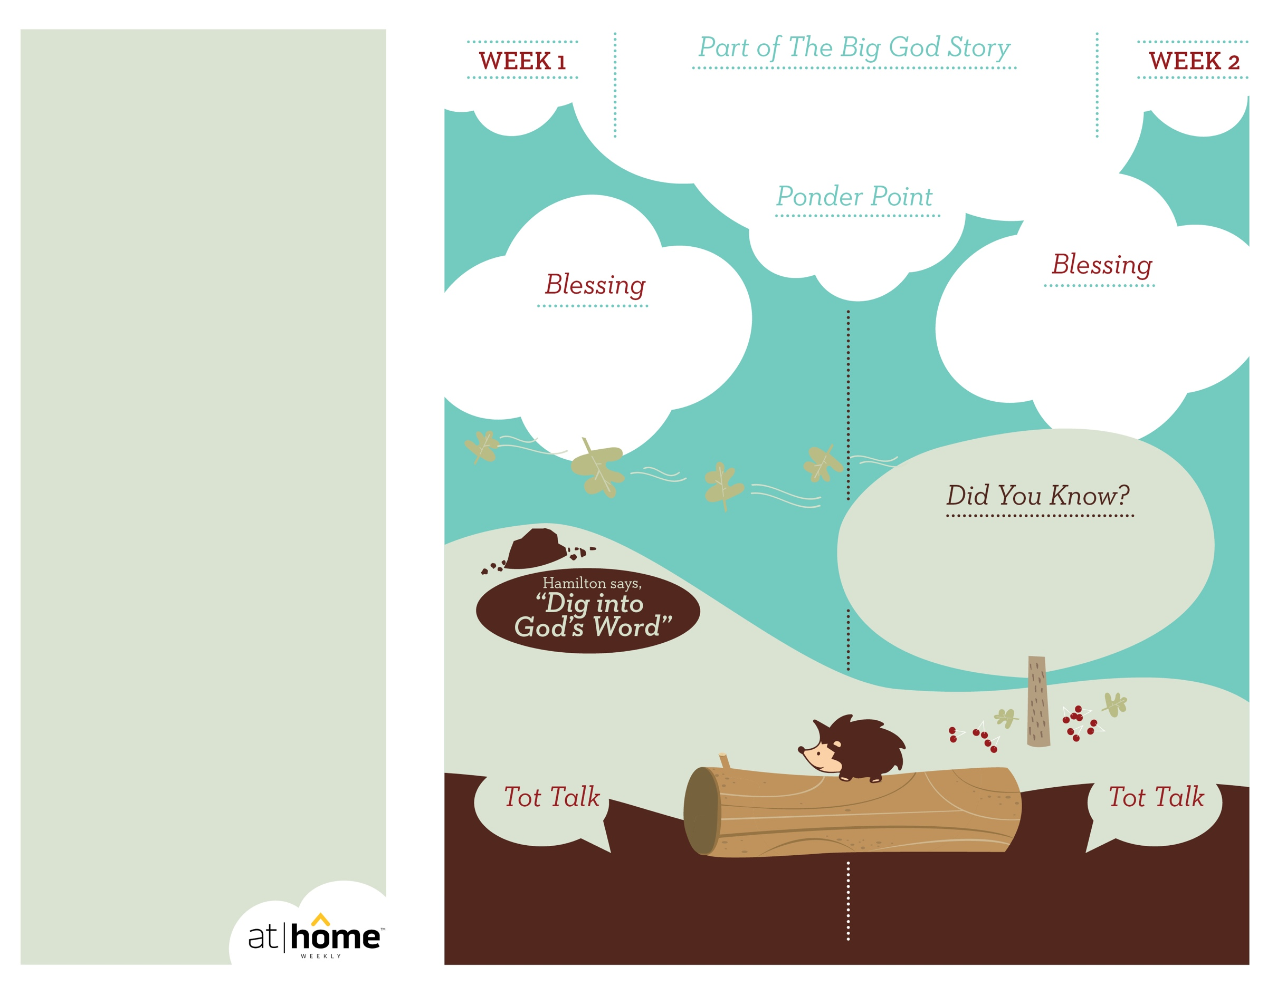

Remind your child that God is always with us. Discuss the fact that He is present in our lives when we are happy, sad, or even scared like the disciples were!

Open a Bible and read Psalm 73:28a:

***“But as for me, it is good to be near God.”***

(Insert your child’s name)**,** ***May you***

***enjoy being near God.***

**Matthew 14:22–33; Mark 6:45–51**

After praying, Jesus walked on the water to meet the disciples, who were out on the lake in a boat. Peter walked out on the water to meet Jesus. When Peter became afraid and began to sink, Jesus saved him.

***Your child may enjoy playing with water.***

***During bath time, give her a few objects***

***and discuss which ones sink and***

***which ones float.***

***Read Matthew 14:28–31.*** After reading, remind

your child that God is with her, just as Jesus

was with Peter.

• The miracle of Jesus walking on water is

one of 37 miracles of Jesus recorded in

the Gospels!

• When Peter felt scared by the

wind and the waves, he began to sink.

(Insert your child’s name)**,** ***God is***

***with you. May you know how good***

***it is to be near Him.***

***God has given parents the***

***privilege of being the primary***

***spiritual nurturers of their***

***children’s faith.***

The At Home Weekly is designed to reinforce that truth by encouraging your family to have time in God’s Word **before your child attends church each week.** It will provide you with ways to introduce The Big God Story and have age-appropriate conversations with your little one as you prepare her for what she will be experiencing in church for the next four weeks.

Research has shown that children between the ages of two and four learn best through repetition. Because of this, TruBlessings will spend two weeks on the same part of **The Big God Story** and the **Ponder Point.**

Each week you will receive a new **Blessing.** A blessing is a prayer of commission, a portion of Scripture, or words of encouragement and guidance. While giving the blessing, you may desire to lay hands on your child as you speak the Scripture or pray a prayer over him.

**Hamilton the Hedgehog** will play a role in your child’s experience in church each week—be sure to ask about him. He loves to **Dig into God’s Word.** The passage of Scripture provided will assist you as you reinforce the Ponder Point. **Did You Know?** has fun facts about this part of The Big God Story for you to share with your child. And **Tot Talk** is simply a conversation starter to assist you as you spiritually parent.

***GOD IS WITH ME***

3.2

3.1

© 2017 David C Cook. TruResources are developed in   
partnership with **ROCK**HARBOR Church and a   
national network of family and children’s ministry   
leaders. All rights reserved. Reproducible for  
church use only.

How did Jesus get to His friends who

were out on the lake? Could anyone

but God do this? NO! Jesus is God.